**Penalty Shootout Game Interface**

**Introduction**

**Target Audience**

The target audience for this penalty shootout game would be young teenagers between the ages of 12-16. To achieve this, I need to make sure that the game is easy and simple to understand. The interface needs to be both attractive and appealing, but also functional and simple so that a young audience would be able to play and use all the features of the penalty shootout game. Simplicity and functionality of the user interface design is very important for this game to be successful. To add interactivity and a fun user experience I will be using football related music in the main menus, button sound effects and suitable football related images and animations. Younger attention spans are important to consider in the user interface design, so colourful images and animations should be used within a simple and consistent menu layout which they are familiar with. This would help reduce their frustration and would enable greater accessibility and navigation. Everyone should be able to play this game with varying experience levels in playing games so the margin for error must be reduced by creating a simple interface.

**Review of Existing Designs**

To be able to design a good user interface for a penalty shootout, I thought it would be important to research and consider other games. This would help me see positives and negatives of the design of the interface and what things I should include in my design so that it is better than other competing products already on the market. I would check the accessibility options, difficulty settings, how easy it is to play the game and if tutorials and their controls are easy to understand when first playing the game. When researching other penalty shootout games, I would also analyse how simple the interface is to use, the gameplay and functionality of the game and what features that I could include in my design which would improve the interaction of my design for the target audience.

**State of the Art**

**Penalty Shooters 2 on 1001Games.com**

The game that I have chosen to research and analyse is the Penalty Shooters 2 game on 1001Games.com (Penalty Shooters 2, n.d.) because it was the best visually looking game out of the collection of games on the internet. I wanted to analyse the visuals, functionality, and ease of use of the interface before developing the design of my penalty shootout game so that I can point out areas of development and improvement.

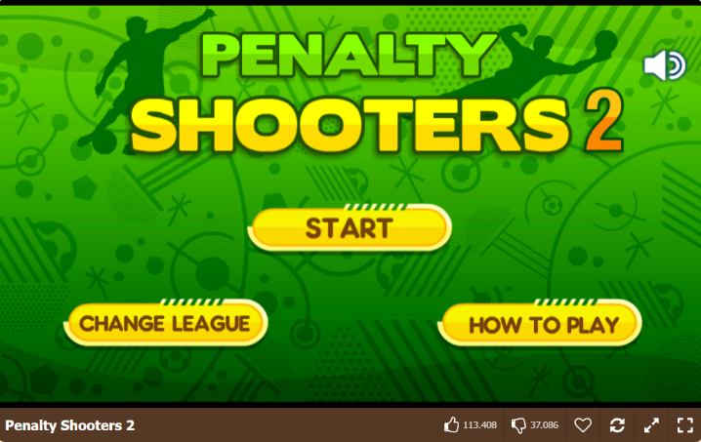

This Main Menu is very well designed, background is very appealing, title is large and pops out at the user well which would be great for my target audience of young teenagers. The images and buttons are simple and maintain a consistent colour. The font is consistent throughout the main menu. There are not too many buttons on-screen at once, there is a speaker icon that turns off the main menu background music when it is clicked on. When the music is turned off, the speaker is crossed out with a “X”, which I think is a good idea, but I think it could be better if the icon turned red when music is turned off. I think the Change League button is a little bit confusing and when I first played this game, I wasn’t sure what this meant and what relevance this had to the gameplay. The largest thing that I was confused, was the absence of a settings or options button. Rather than have a Change League button on the main menu, it would be much better to either have a settings button or icon in the corner of the screen to give the player much greater accessibility options.

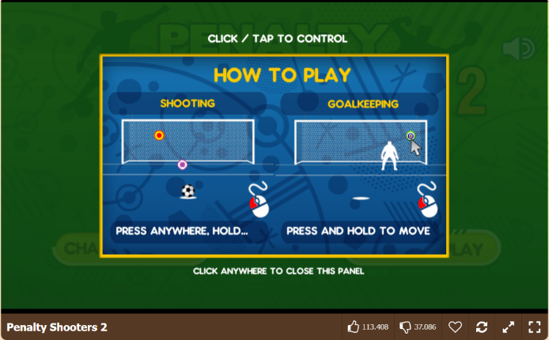

This is the How to Play menu when you click that button on the Main Menu. A small window appears dimming the main menu in the background helping you focus your attention on the How to Play screen in the middle. The window has clear instructions, where you must click anywhere to close the How to Play panel. The controls are simple to understand for both shooting and goalkeeping, however there is no tutorial where everything can be explained and put into practice for users who are playing this game for the very first time. This would be a much better method of teaching the player the mechanics and controls of the game rather than with images. When playing the game, the controls are inaccurate because it has not been explained that holding the mouse button makes you shoot the ball higher.

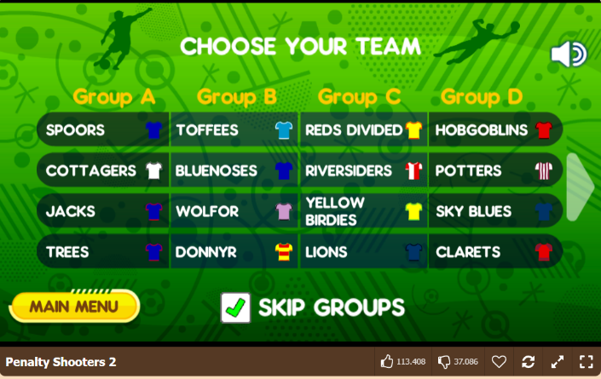

After clicking the Play button, you are prompted to choose the team you want to play with. A positive from this menu is that the user can return to main menu by clicking the yellow button and once a team is clicked on, a Next button appears that takes you right into the game. This menu is very confusing because there are 2 pages of random teams that have been made up. They have no relevance to real life which could make it difficult for you to choose any team and since your choice doesn’t influence the difficulty of the penalty shootout, there is no reason to choose a particular team over another one. It could be better if the selection screen was not so clustered with options and had a scroll selection menu that contained the star level of the team and the score for their attack and defence. This would give the user an indication of how difficult or strong the team is, therefore making the game more entertaining and adds a layer of strategy to who they decide to pick. There was some confusion on what the Skip Groups tick button does, but after selecting it, it puts you in a group stage where you play 3 games against 3 teams, where the top 2 teams earn a spot in the tournament bracket. However, this was feature was not explained by the game.

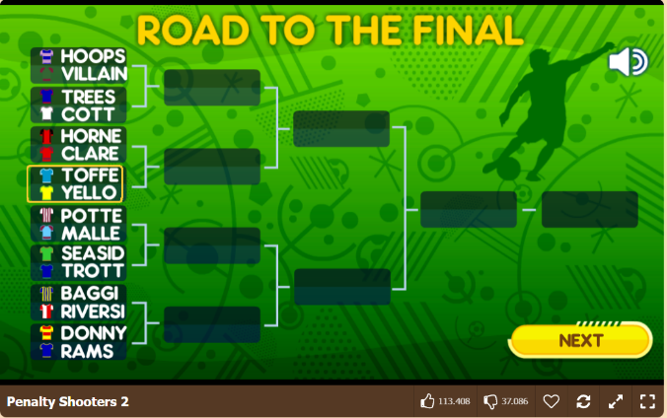

Right before you get put into the game, you get a quick look at the tournament bracket in which you are playing in and who you are against. This layout is very simple to understand, however I think a quality-of-life improvement that would make it better, would be if the bracket was smaller and they were split to have 2 brackets on both sides. This would make room on the screen for the scores to be displayed underneath the bracket after your game is played, so that you can see the winner of each bracket and how well each team is doing over the duration of the tournament.

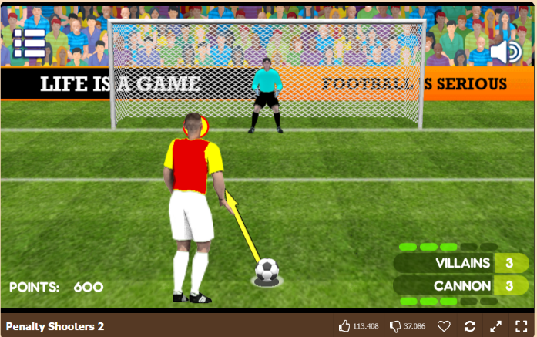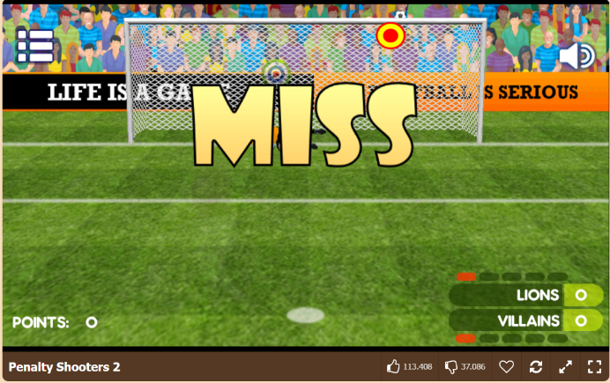

In the game itself, we have great visuals with fans, banners, footballer, and goalkeeper animations. When shooting, the arrow and target are moving on their own and the user must click when the target is aiming in the direction they want to shoot at. This is a good way of making it more difficult to choose where you want to aim at, meaning it is possible to completely miss on either side of the goal if you mistime your mouse click. The harder mechanic to execute is the aiming the shot higher because the target continues to move from side to side as you hold your mouse key. Goalkeeping seems to be easier because there is a split second, where a target appears where the shot is going. This makes it easier to save a shot because there is more focus on reflex rather than preparation. The menu with the scoring system in the corner is great and simple to understand with the number score of penalties scored and colouring the tab either red or green depending on if you scored or missed your penalty. So, during the game you can see if you are still able to win if you are 1 goal behind, increasing your anticipation and dopamine levels. This therefore makes the game a lot more entertaining. There can still be improvements that can be made to this menu because the top left menu button sends you back to the main menu without asking you if you are sure that you want to quit. This means that if you accidentally press this button during a game, you will lose all your progress without asking you if you are sure you want to make this decision. Also, there is no pause button, so you will have to continue playing if you do not want to lose all your progress. I am not sure how the points system works in this game because once again it has not been explained or what this score is used for. This can be confusing for first time players because they might not be sure how to get a high score or if winning a penalty shootout is more important. It seems that this may not be necessary or should at least be explained to the player in the How to Play menu.

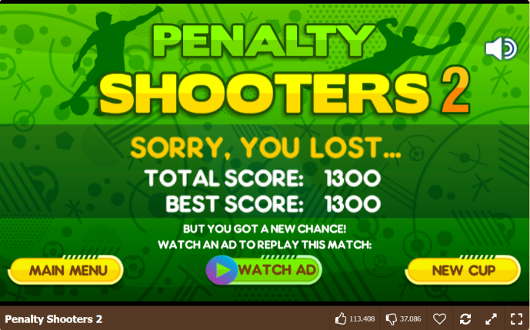

If you lose the game, you are prompted to this screen showing your total score and your best score. From this menu you can return to the main menu, can take part in a new cup straight away without going through all the menus again. This ensures ease of access and makes it easier to restart a cup instead of selecting your team again. The user can restart their game by clicking the green watch ad button, however when I clicked on this, I didn’t have to watch an advertisement and instead I was immediately able to play the same match of the tournament again. I am not sure if this feature is working properly, however it should be that if no advertisement is available or there is no internet connection, this feature should be disabled.

**Methodology of Testing**

For the development of my Penalty Shootout game, I have made sure to review similar games already on the market and identify potential areas of improvement for the prototype of my game. I have tested the game in terms of its gameplay, the user interface design, and the overall user experience. When testing the effectiveness of my design, I ensured that I showed this game to the target audience of young teenagers so that they can access the simplicity, user-friendliness, and the performance of the game interface. To achieve good human-computer interaction, I have conducted summative testing to 9 young teenagers to test the effectiveness, efficiency, engagement, and error tolerance. Unbiased user feedback ensures that the interface meets the technical standards while also providing an engaging and enjoyable experience for the young teenagers on both PC and mobile devices.

**Development of Penalty Shootout Game**

|  |  |
| --- | --- |
|  |  |
|  |  |
|  |  |
|  |  |
|  |  |
|  |  |
|  |  |
|  |  |
|  |  |
|  |  |
|  |  |

The game's Main Menu interface was meticulously designed in Adobe Photoshop with various tools and gradients to enhance interactivity. The use of vibrant green backgrounds and gradient buttons caters to the young target audience, ensuring visibility and engagement. Icons like the settings gear maintain consistency, and a football player at the centre provides a cartoonish introduction to the football-themed game. The inclusion of a small logo and game title enhances completeness. Interactive elements such as animations, sound effects, and background music contribute to a dynamic user experience. The Credits Menu retains the Main Menu's visual style with blurred background effects for focused viewing. The Stats Menu offers game statistics and a leaderboard, catering to the teenage audience's interest in analytics. The Options Menu, with an artistic flair, includes accessibility features like language selection, contrast adjustments, and dark mode. Sliders control sound and music volumes, and version information is displayed for issue tracking.

Upon clicking the Play Button, users navigate through Play Menus with tabs for different game modes. The design ensures clarity with a "Choose your Gamemode" prompt, and interactive elements like scrolling tabs and unique visuals for each tab enhance engagement. The Tutorial Menus simplify controls using visuals for PC and mobile versions, promoting a simple yet effective learning experience. Penalty-taking and goalkeeping mechanics are explained through visuals and minimal text, ensuring ease of understanding. The Tutorial includes tips and tricks for scoring and saving penalties, emphasizing timing and precision. In-game penalty scenarios incorporate realistic elements like fan cheers and player reactions.

Multiplayer interfaces for PC and mobile versions feature different coloured buttons representing various modes. Visual designs include user icons and symbols for connection types, providing a variety of ways to play against friends. Arcade Mode menus display team selection, difficulty, and unlocking objectives, encouraging varied gameplay. Tournament Mode follows a similar structure to Arcade, maintaining consistency. Tournament brackets use flags for teams, adding colour and simplicity, while animations and sound effects enhance interactivity. Winning and losing screens in tournaments incorporate celebratory or disappointed elements, providing a dynamic end to the gameplay experience.

*[Please see Appendix A for more details.]*

**Results**

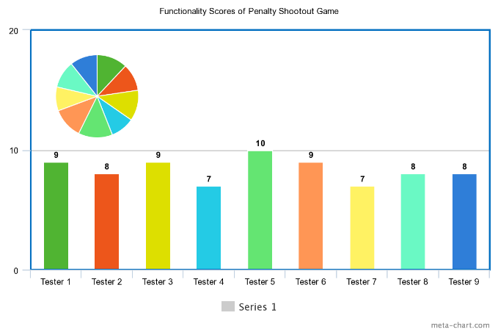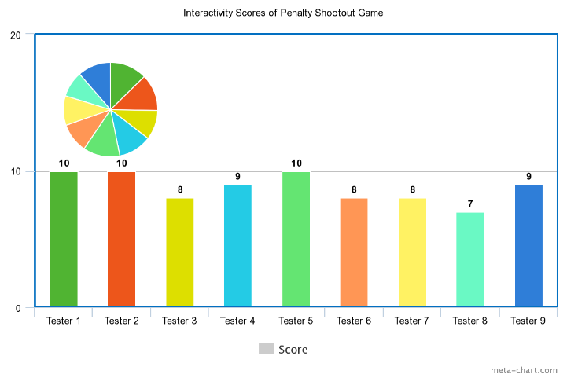

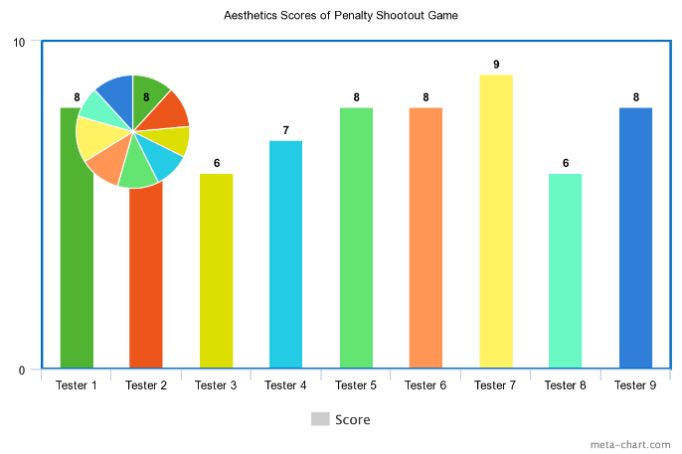

**Conclusions**

The results of the testing have been quite high with the functionality average being 8.3 out of 10, the interactivity average is 8.7 out of 10 and the aesthetics score is 7.5 out of 10. From the rests of the testing, we can see that the aesthetics of the game have achieved the lowest score. This could be because the animations contain placeholders for the first version of the game and the game itself, does not yet have player faces and different kit colours for each team. The interface is quite simple which was the main goal and was not supposed to be very complex. Also, some of the return buttons have been missing on certain menus which could further improve the functionality. The design of the Penalty Shootout game should be functional, operational, and visually appealing which the game has passed due to the high scores overall by the 9 testers.

**Limitations**

Due to the low budget for the project, the first versions of the Penalty Shootout game would be quite basic especially when it comes to animations and gameplay, however, these are the next areas of improvement to improve the aesthetics and interactivity. The small development team have made the development of the UI has made it difficult to develop a fully functional and aesthetic game for multiple platforms in a short time frame. The focus of the first version of the game was to be interactive and build a good base to add new teams, new modes, improve animations and improve player models.

**Future Work**

If we had more resources for this project, we would improve the gameplay of the game itself by improving the shooting and saving animations of the players. Adding the unique player faces, national team kits to improve the aesthetics of the game, making the game feel much more realistic. You could potentially pick the 5 players from the team that you wish to take the penalties, they could each have their own scores. We could have done a step-by-step tutorial that freezes and explains what to do on screen rather than making the user take in all the information at the start. These are more advanced features that we made sure that we could build on if we had more time and resources to develop a more complete product. It was important for us to ensure that the product was fully operational, gameplay was simple and there was room for improvement and extra features to be implemented.

**References**

*alicdn.com*. (n.d.). Retrieved from alicdn.com: https://ae01.alicdn.com/kf/Sb446a82afca4421991e11d2bf6a36cf2O/Soccer-Field-Background-Football-Goal-Post-Ball-Game-Stadium-Spotlight-Photography-Backdrop-Lawn-Sports-Club-Fitness.jpg

*AlphaCoders*. (n.d.). Retrieved from alphacoders.com: https://images.alphacoders.com/968/968421.jpg

*Alzheimers.org.uk*. (n.d.). Retrieved from Alzheimers.org.uk: https://shop.alzheimers.org.uk/cdn/shop/products/9979a441dd671ffa16b4e0592d958679_1200x.jpg?v=1660839843

Baddiel, S. &. (n.d.). *Three Lions*. Retrieved from Three Lions: https://www.youtube.com/watch?v=Zgk7xeIeSxQ&themeRefresh=1

*bittbox.com*. (n.d.). Retrieved from bittbox.com: https://www.bittbox.com/wp-content/uploads/2023/03/Spacebar-03.png

Bros, A. &. (2016, 02 17). *Samba de Janeiro*. Retrieved from Samba de Janeiro: https://www.youtube.com/watch?v=7Q0TbNP01jc

*cdn.icon-icons.com*. (n.d.). Retrieved from cdn.icon-icons.com: https://cdn.icon-icons.com/icons2/1875/PNG/512/devices_119983.png

*cdn.pixabay.com*. (n.d.). Retrieved from cdn.pixabay.com: https://cdn.pixabay.com/photo/2020/04/26/11/56/amazon-stars-5094895_1280.png

*cdn-icons-png.flaticon.com*. (n.d.). Retrieved from cdn-icons-png.flaticon.com: https://cdn-icons-png.flaticon.com/512/118/118221.png

*cdn-icons-png.flaticon.com*. (n.d.). Retrieved from cdn-icons-png.flaticon.com: https://cdn-icons-png.flaticon.com/512/6956/6956337.png

*cdn-icons-png.flaticon.com*. (n.d.). Retrieved from cdn-icons-png.flaticon.com: https://cdn-icons-png.flaticon.com/512/659/659992.png

Database, S. E. (2022). *Crowd Aww Sound*. Retrieved from Crowd Aww Sound: Goal Sound Effect

Database, S. E. (2022). *Large Football Crowd*. Retrieved from Large Football Crowd: ARCADE RETRO CLICK

Delaiglesia, S. (n.d.). *Tumblr*. Retrieved from Tumblr.com: https://64.media.tumblr.com/5594ee771508d7dfb9a4b8a28a0080ba/tumblr_oxr9c6Xu741ssa155o1_1280.png

DoomerReflex. (2021). *HALO INFINITE*. Retrieved from HALO INFINITE: https://www.youtube.com/watch?v=VOTKeW2WcUA

*Goawall*. (n.d.). Retrieved from Goawall.github.io: https://goawall.github.io/posts/green-cartoon-wallpaper/

*Google Apis*. (n.d.). Retrieved from googleapis.com: https://storage.googleapis.com/pod_public/1300/159322.jpg

Googleeman. (2022). *Crowd Shouting*. Retrieved from Crowd Shouting: https://www.youtube.com/watch?v=eb3JFlkVWDo

*Iconfinder*. (n.d.). Retrieved from cdn3.iconfinder.com: https://cdn3.iconfinder.com/data/icons/streamline-icon-set-free-pack/48/Streamline-75-512.png

*Iconfinder.com*. (n.d.). Retrieved from Iconfinder.com: https://cdn2.iconfinder.com/data/icons/media-controls-5/100/close-512.png

*iStockphoto.com*. (n.d.). Retrieved from iStockphoto.com: https://media.istockphoto.com/id/1403689288/vector/goal-soccer-1.jpg?s=612x612&w=0&k=20&c=A9Hc0_P_sy3n9Hp9Cceal0HYjiatdXAPFHvonwHQjjY=

*iStockphoto.com*. (n.d.). Retrieved from iStockphoto.com: https://media.istockphoto.com/id/1283551334/photo/young-african-soccer-player-man-isolated-white-background-silhouette-shadow.jpg?s=612x612&w=0&k=20&c=jQSFuIFI1xp9Q8LcoefpApeJn7deiVeJZvbN_1SIE7k=

Oggy, O. (2021). *Crowd Cheering*. Retrieved from Crowd Cheering: https://www.youtube.com/watch?v=4ssFUfihsiU

PacTube. (2021). *Goal Sound Effect*. Retrieved from Goal Sound Effect: https://www.youtube.com/watch?si=YU5gQzwHJcl7IOHa&v=aXqmSuTmHok&feature=youtu.be

*Penalty Shooters 2*. (n.d.). Retrieved from 1001 Games: https://www.1001games.com/sport/penalty-shooters-2

*Pinimg.com*. (n.d.). Retrieved from Pinimg.com: https://i.pinimg.com/736x/08/17/a5/0817a511b7ce7fdc3e1acf84159f0491.jpg

*Pixabay*. (n.d.). Retrieved from Pixabay.com: https://cdn.pixabay.com/photo/2023/05/18/13/40/cristiano-ronaldo-8002334_1280.png

*png.pngtree.com*. (n.d.). Retrieved from png.pngtree.com: https://png.pngtree.com/png-vector/20220726/ourmid/pngtree-loading-icon-dot-ring-vector-transparent-png-image_6061369.png

*png.pngtree.com*. (n.d.). Retrieved from png.pngtree.com: https://png.pngtree.com/png-clipart/20230105/original/pngtree-fifa-world-cup-trophy-png-image_8873382.png

*Pngall.com*. (n.d.). Retrieved from Pngall.com: https://www.pngall.com/wp-content/uploads/5/Pause-Button-Transparent.png

*Pngtree.com*. (n.d.). Retrieved from Pngtree.com: https://png.pngtree.com/png-vector/20190419/ourmid/pngtree-vector-play-icon-png-image_956416.jpg

*Printler*. (n.d.). Retrieved from printler.com: https://prod-printler-front-as.azurewebsites.net/media/photo/130910.jpg?mode=crop&width=727&height=1024&rnd=0.0.1

Root, R. (n.d.). *Switch Loading Music*. Retrieved from Switch Loading Music: https://www.youtube.com/watch?v=A_tPEy0Ka-4

*Soccer Shootout*. (n.d.). Retrieved from Games Graveyard: https://www.cbc.ca/kidscbc2/games/games_graveyard/soccershootout

soundbag619. (n.d.). *ARCADE RETRO CLICK*. Retrieved from ARCADE RETRO CLICK: https://www.youtube.com/shorts/yKVTa0B_Y5s

*static.vecteezy.com*. (n.d.). Retrieved from static.vecteezy.com: https://static.vecteezy.com/system/resources/previews/023/204/872/original/confetti-illustration-for-festival-background-colorful-tinsel-and-confetti-explosion-multicolor-confetti-on-transparent-background-event-and-party-celebration-festival-elements-fre

Studios, A. &. (2022). *Body Thud*. Retrieved from Body Thud: https://www.youtube.com/watch?v=11bxTXllabk

*svgrepo.com*. (n.d.). Retrieved from svgrepo.com: https://www.svgrepo.com/show/350417/user-circle.svg

*t3.ftcdn.net*. (n.d.). Retrieved from t3.ftcdn.net: https://t3.ftcdn.net/jpg/02/15/03/60/360_F_215036012_WA9UcTDcLoSbQeoxantIVwYAS0Kg2BtP.jpg

Tech, N. (2021). *All Airpods UI Sounds*. Retrieved from All Airpods UI Sounds: https://www.youtube.com/watch?v=DjT_HtMsLUQ

*thenounproject.com*. (n.d.). Retrieved from thenounproject.com: https://static.thenounproject.com/png/15431-200.png

*Thenounproject.com*. (n.d.). Retrieved from Thenounproject.com: https://static.thenounproject.com/png/1921206-200.png

*thumblr.uniid.it*. (n.d.). Retrieved from thumblr.uniid.it: https://thumblr.uniid.it/product/256193/fbe9ff6341ec.jpg

*vecteezy.com*. (n.d.). Retrieved from vecteezy.com: https://static.vecteezy.com/system/resources/previews/021/013/593/non_2x/key-lock-icon-on-transparent-background-free-png.png

*Vecteezy.com*. (n.d.). Retrieved from Vecteezy.com: https://static.vecteezy.com/system/resources/previews/010/851/405/original/computer-mouse-icon-free-png.png

*Vecteezy.com*. (n.d.). Retrieved from Vecteezy.com: https://static.vecteezy.com/system/resources/thumbnails/021/013/589/small_2x/click-touch-icon-isolated-on-transparent-background-free-png.png

*Vector Stock*. (n.d.). Retrieved from cdn3.vectorstock.com: https://cdn3.vectorstock.com/i/1000x1000/47/92/goalkeeper-icon-vector-33744792.jpg

Vector Stock. (n.d.). *Vectorstock.com*. Retrieved from Vector Stock - Return Icon: https://cdn4.vectorstock.com/i/1000x1000/23/63/back-arrow-icon-on-white-background-vector-21942363.jpg

*veryicon.com*. (n.d.). Retrieved from veryicon.com: https://icons.veryicon.com/png/o/internet--web/web-video-clip/play-332.png

*Vexels.com*. (n.d.). Retrieved from Vexels.com: https://images.vexels.com/media/users/3/321764/isolated/preview/045ad2f70f5a85f3a6388f3d29520429-world-cup-goalkeeper-player.png

White, R. (2014, 05 09). *Viva Vida*. Retrieved from Viva Vida: https://www.youtube.com/watch?v=cKhEZfE6XbQ&list=RDcKhEZfE6XbQ&start_radio=1

**Appendix A: Additional Design Details**

**Main Menu**

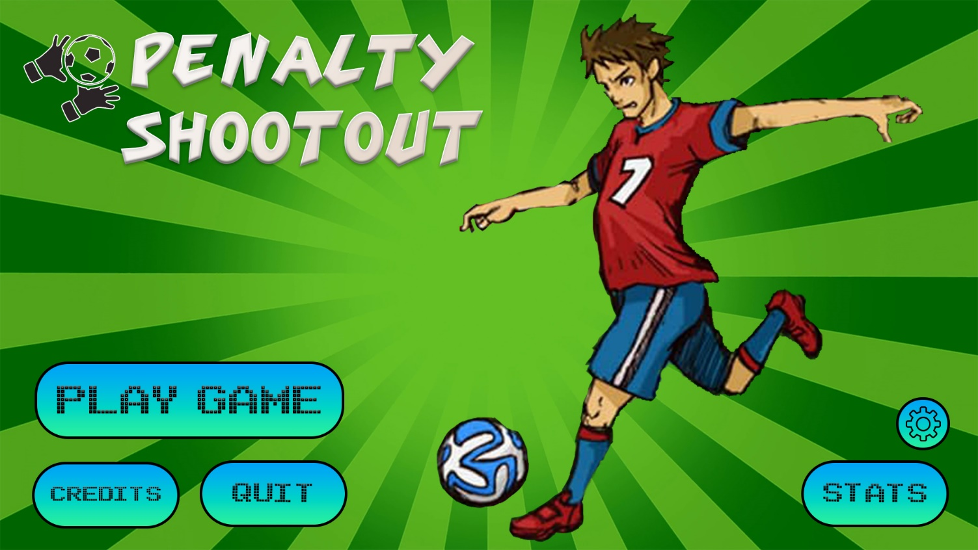

The Main Menu interface was designed in Adobe Photoshop with many different tools and gradients to make the main menu more interactive. The use of colour in green backgrounds (Goawall, n.d.) and gradient of the buttons was important for the target audience because young audiences can easily see the buttons. I have made sure that they are large and visible by creating large rectangles with curved edges, a smooth blue fill gradient inside the buttons with large arcade font which are often used in this type of arcade and mobile games. Since the Settings icon was not as important as the rest of the buttons on the main menu, I decide to keep the style consistent but instead of having text, it would have a recognisable settings gear icon(Iconfinder, n.d.)*.* The football player in the middle of the screen was chosen because it gives a cartoon feel and gives a good introduction to what the game is about(Soccer Shootout, n.d.)*.* The player and target audience would very quickly be able to recognise that they are playing a football game. In the top left corner, I needed a small logo and name of the title of the game to make the main menu feel more complete, therefore I found an icon of football goalkeeper gloves stopping a football (Vector Stock, n.d.). I kept the name of the game simple with “Penalty Shootout” so that the player has no confusion on what the game is about.

As the main menu is the first screen the player sees, when they first open the game, it is therefore key to make sure that the main menu contains all the necessary navigational buttons and has many interactive elements such as buttons, images, animations, text, and logos. To make the menu feel unique and interactive, I made sure to stay consistent throughout the menus of the game with the visual style of the buttons. The Play Button would have a smooth scroll to the side animation and the player in the middle of the screen would have their back leg move slowly back and forwards to encourage the player to play the game. Visuals are important but I have also considered other interactive elements such as sound effects and background music. The Main Menu screen will also have a football related music playing the background such as (White, 2014)*,* (Baddiel, n.d.)*,* (Bros, 2016).Each button when clicked will slightly change the colour of the button to a slightly darker shade of blue and the text will change to italics for 1 second while the game transitions you to the next menu screen. Each button will make an arcade button sound effect when clicked on (soundbag619, n.d.). By having a good mix of sound effects, music, animations and visual effects, the main menu would be best suited for a young target audience and therefore encourage them to play this game more often.

**Credits**

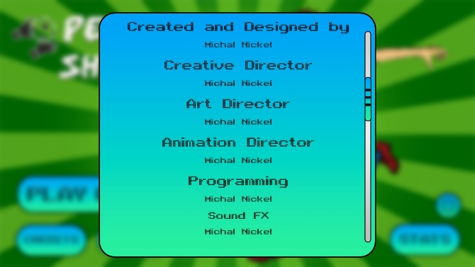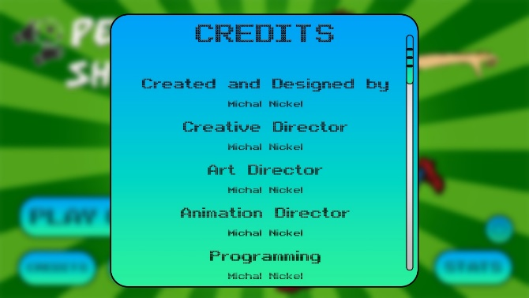

The Credits Menu was also designed in Adobe Photoshop with similar buttons, fonts, and colours from the Main Menu. When you click the Credits button on the Main Menu, the Main Menu is still visible in the background, however it is blurred to give a visual effect that allows the player to focus on what is in the middle of the screen. I used the same button colour and font from the Main Menu to maintain consistency throughout the interface. The Credits button contains the names of the developers for each sector of the game and automatically scrolls down slowly which is indicated by the scroll bar on the right side of the button. I made sure to include this so that player knows how long the Credits screen is, as it slowly moves down to display all the developer’s names. The scroll bar adds more functionality as the player can also drag the bar up or down wherever they want. If they want to exit the Credits Menu, then the player can simply click off screen on the blurred background menu and they will return to the Main Menu.

**Stats**

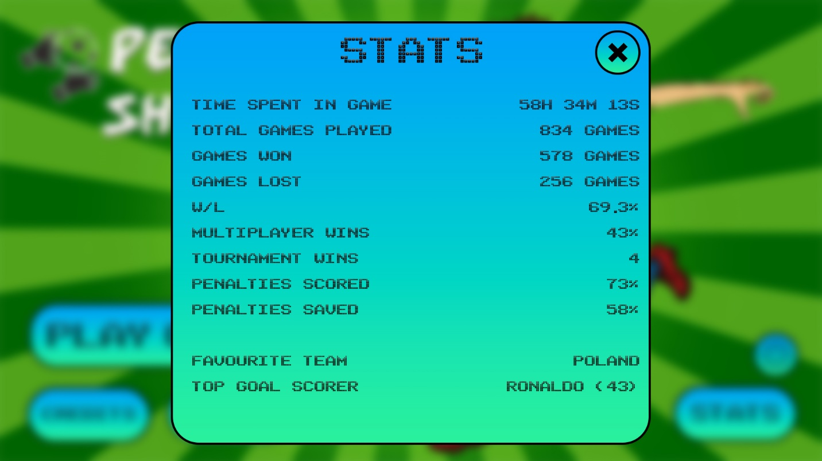

The Stats Menu was designed with Photoshop using the template of other pages from the Main Menu with similar buttons, fonts, and colours. For the Penalty Shootout game to be more interactive, I thought it would be interesting to have a Statistics/ Leaderboard menu containing in-game statistics. The target audience of young teenagers like to see statistics, so that they can analyse their performance and skill in the game. In the design of the Statistics page, I have made sure to maintain a consistent layout throughout and not contain long text. The Stats page is simple to read and is presented in many different styles which contain the hours, minutes and seconds played, the number of games played, won, and lost, also presented in a win to loss percentage. To add some personalised characteristics, I thought it would be interesting to include the player’s favourite team which is automatically calculated based on what national team the player chose most often. The top goal scorer’s name is displayed on the bottom of the Statistics page, showing the player who scored the most penalties for their team and how many. All of this would make the Penalty Shootout game more interactive because it provides the player with visualisation of their skill level by breaking down each element of this game and providing real-time updates. To return to the Main Menu, then the player simply needs to click the x button on the top right of the stats screen.

**Options**

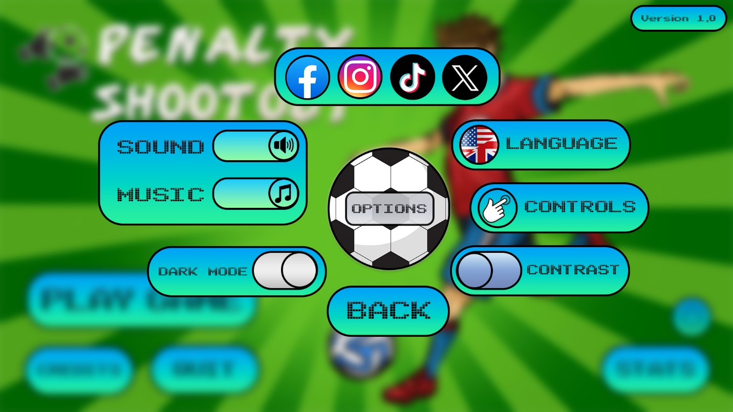

The Options Menu interface is also designed in Adobe Photoshop, but I have decided to give this menu a much greater artistic flair to make it more visually appealing for young teenagers. The Options menu needs many accessibility options, so to make it visually appealing and fully functional I have included a large football in the middle of the screen with buttons around it.

The football would be slowly rotating clockwise and the Options text in the middle would stay still. On top of the football, we have the 4 main social media icons which the player would be able to click on, to transfer them to the corresponding social media accounts on the internet. The language button is by default set to English but by clicking the button, the player can change the language of the menus to French, Spanish, German or Italian. Depending on the language the player has selected, the flag on the button will also change. When the Controls button is clicked on, the menu controls will be displayed on screen and how to navigate through the menus. The contrast button when toggled on, it will increase the colour contrast of the menus and the buttons. This would help the target audience of young teenagers with visual impairments or accessibility needs, to be able to play this penalty shootout game without any issues. With the rise in popularity of the dark mode, I have decided to also include this in the design of the penalty shootout interface as a toggle switch because it would help reduce eye strain and improve energy efficiency. The final option in the settings menu is the sound and music sliders. Each of them has their own icons and the player would be able to drag and adjust the circle handle to adjust the volume percentage for both sound effects on buttons and the background music. This is a much better alternative than a on and off switch because the user can slightly turn down and adjust the interactive sound effects to their preferred settings configuration. The player can easily quit to the Main Menu by clicking the large BACK button under the football. On the top right of the screen a small button is displayed showing the current version of the game that is being played. This is good because if any bugs, glitches, or errors are discovered, they will be able to be easily logged for issues of the current version of the game so that they can be improved upon and resolved.

**Quit Game**

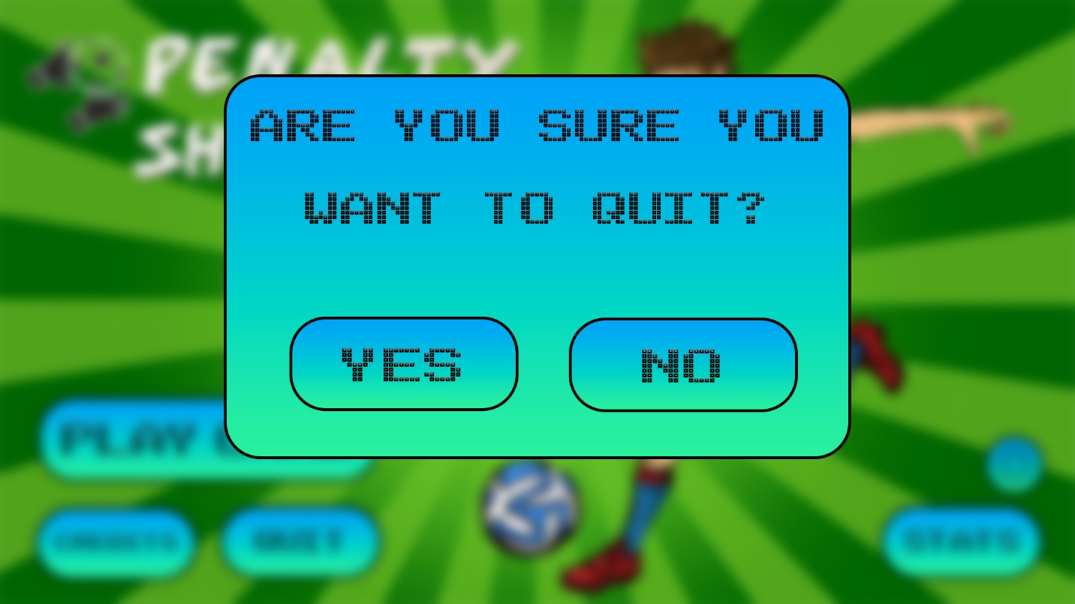

The final page of the Main Menu is the Quit Menu in Adobe Photoshop with consistent buttons. I have chosen for the Quit button not to automatically turn off and exit the game. This would be because it would be annoying if the button was clicked on accidentally and not have the option to revert this mistake. This would be more time efficient in helping reduce the time to revert an accidental mistake by asking the user is they are sure they want to quit the game. If they click yes then the game Penalty Shootout game will turn off and if they click no, then they will return to the Main Menu.

**Play Game**

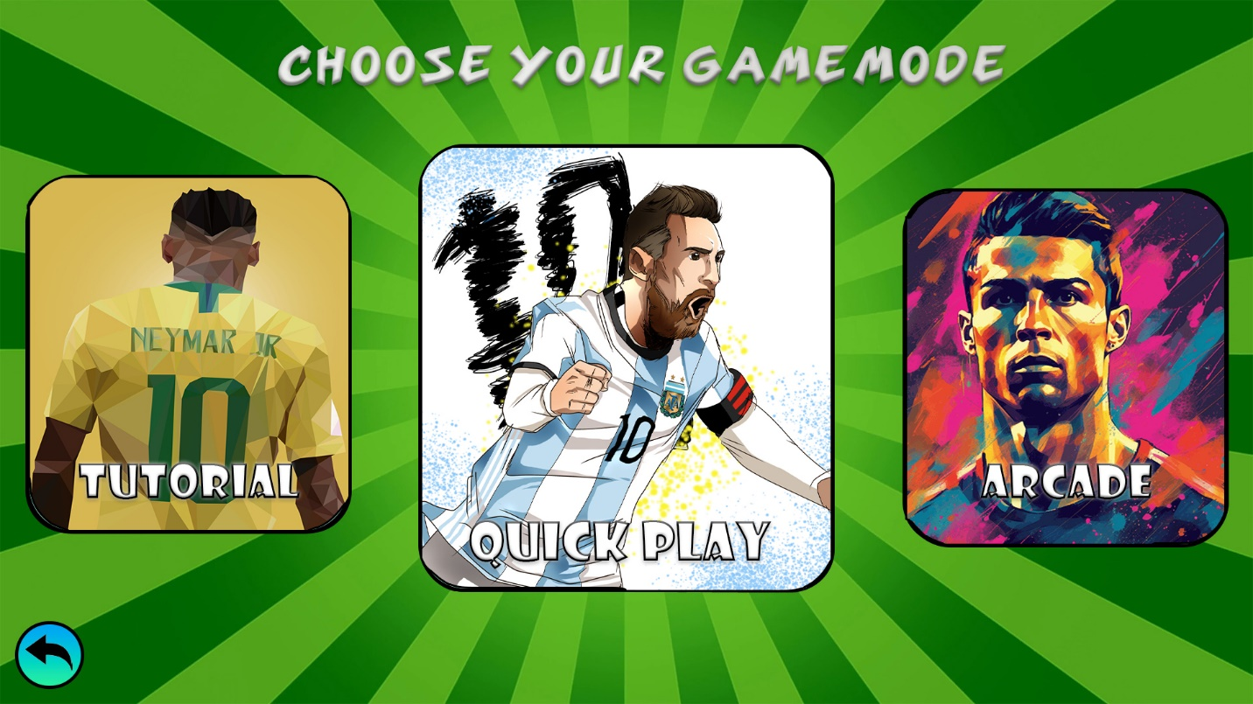

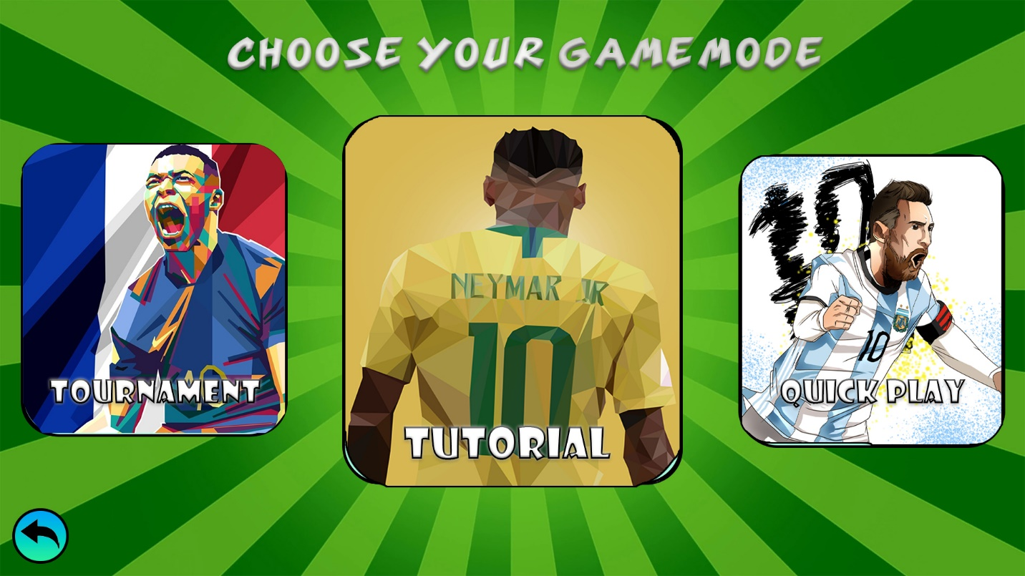

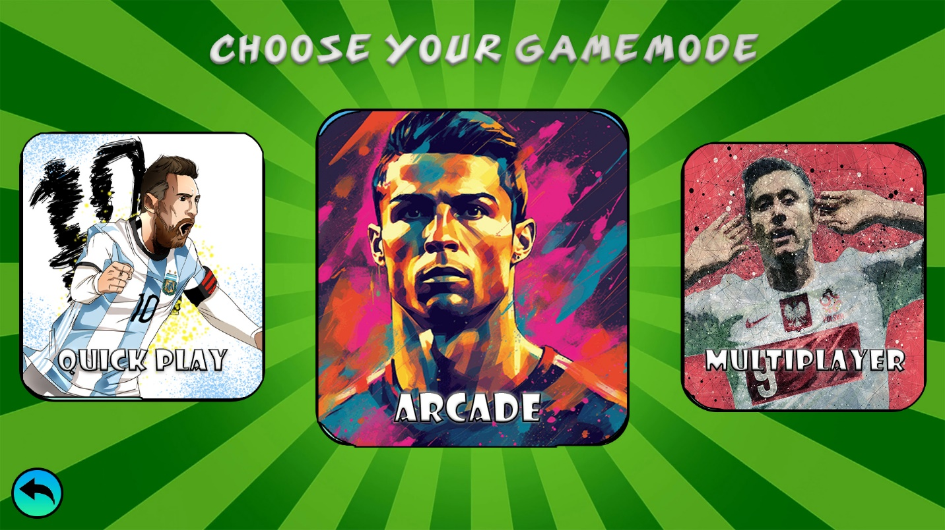

When the player clicks on the Play Button on the Main Menu, they will be moved to the first Play Menu screen where they have large tabs they can click on, to play whatever game they want. All these tabs have been designed in Adobe Photoshop using the same green background from the Main Menu to maintain consistency of the interface (Goawall, n.d.). So that it is clear what the player must do on the Play Menu, I have decided to include text at the top of the screen saying “Choose your Gamemode” to instruct the player to choose what they want to play. The player can return to the Main Menu because I have included a return icon button in the bottom left corner using the same style of the rest of the buttons across the Penalty Shootout game, so it is highly visible (Vector Stock, n.d.).

When you first click the play button, there is a very quick scroll animation for 1 second, letting the player know that they can scroll the tabs from side to side to play other modes of the Penalty Shootout game. The modes for the game are Tournament, Tutorial, Quick Play, Arcade, Multiplayer and with Quick Play being the one in the middle. The tab in the middle, is the largest one while the tabs on either side are slightly smaller which helps focus the player’s attention on the select larger tab. To make the interface more interactive, only the middle tab can be clicked, meaning that the player will have to either click on the tabs on either side to quickly scroll to the side to have that tab in the middle, or they can manually drag the tabs left and right to select the game they want to play. The scroll will also make an arcade sound effect every time the player transitions to the next game mode. When the tab in the middle is changed, the next game modes that originally were not visible on screen will move to become the side buttons. This would make the interface more interactive because there would be a seamless transition of scrolling for when the user reaches the end, meaning the tabs on the other side smoothly appear on the end.

To make each tab feel unique, I have decided to use fan art of popular international football players from around the world which the target audience can recognise. This would be better than having images of football players because an interface should be simple and should maintain the same colourful graphics throughout to attract young teenagers to play all these game modes. For the Tutorial tab, I have decided to use fan art of Neymar Jr. from Brazil (Google Apis, n.d.), for Quick Play I have used Lionel Messi from Argentina (Delaiglesia, n.d.) and for the Arcade tab, I have used Cristiano Ronaldo from Portugal (Pixabay, n.d.). The final two game modes, Multiplayer and Tournament have the fan art of Robert Lewandowski from Poland (AlphaCoders, n.d.) and Kylian Mbappe from France(Printler, n.d.).

**Tutorial**

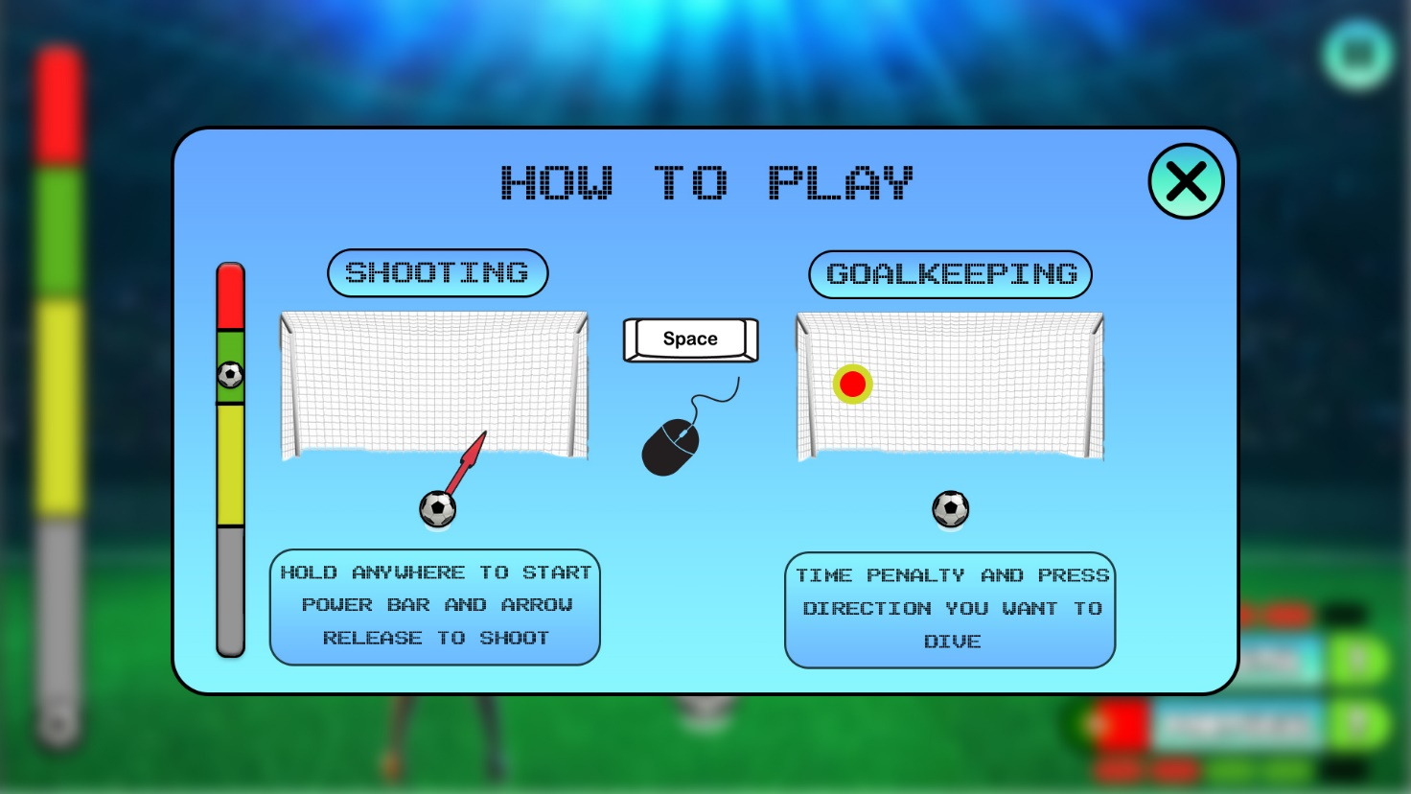

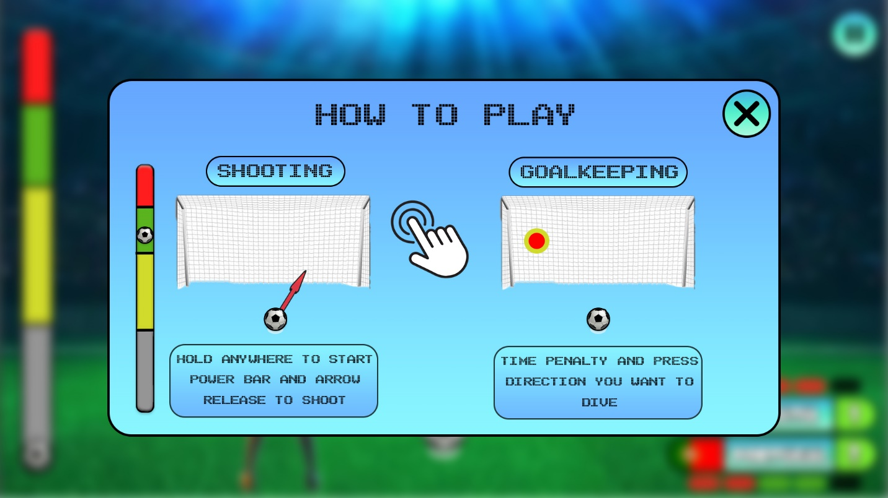

The Tutorial Menus have all been designed in Photoshop to be able to create visually appealing graphics which would be good for the target audience of young teenagers because they are simple understand. This is the Tutorial menu for players playing on a PC because it contains the mouse and keyboard controls on screen of how to play the Penalty Shootout game. The game can be seen in the background; however, it is blurred to focus the target audience of looking at the centre of the screen at the How to Play menu. The PC controls, the space bar (bittbox.com, n.d.) and mouse (Vecteezy.com, n.d.), meanwhile the Mobile version of the game has the touch icon (Vecteezy.com, n.d.) in the middle of the screen. This makes it simple to read and understand How to Play the Penalty Shootout Game. To move onto the next menu of the Tutorial, all the player needs to do is click the large X icon (Iconfinder.com, n.d.) in the top right of the screen.

The simplicity and consistency of the controls was very important in the design of the interface because rather than having many words to explain how to play the game, it would be better to show the player how to score and how to save penalties. On the left, we have Shooting, and on the right, we have the Goalkeeping examples. Both have a goal (iStockphoto.com, n.d.) and a football to show an example of how the game mechanics’ work. The Shooting has an extra power bar on the side and has a very short description underneath to explain to the player that they must hold the space bar or the mouse button to start the power bar and arrow moving side to side. Goalkeeping is also very simple, telling the player to time the penalty at the last moment by clicking the target which shows the approximate location of where the shot is moving.

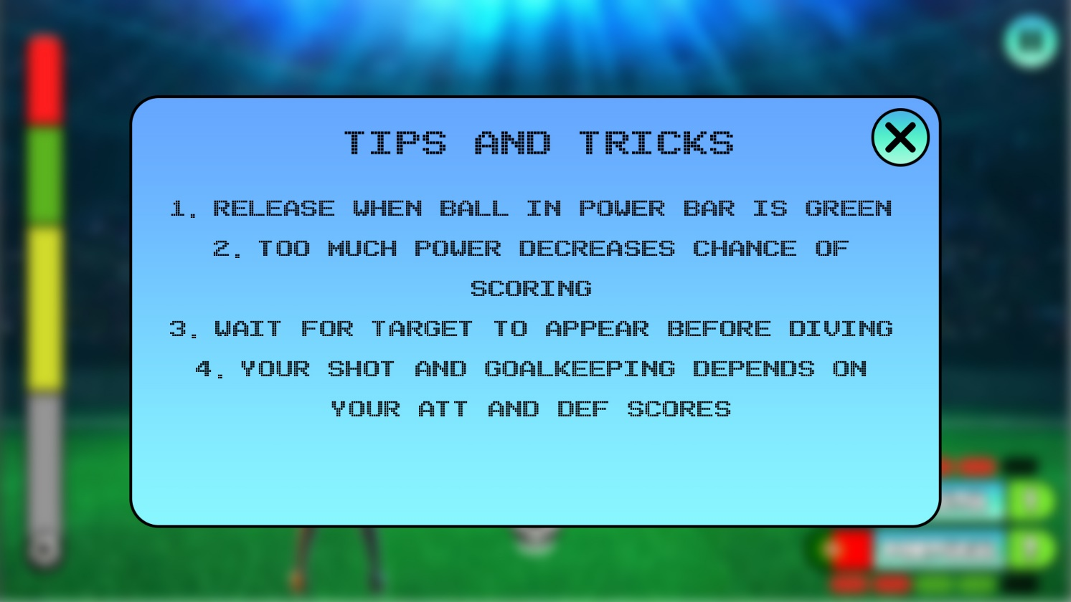

This is the next screen of the Tutorial menu which presents the player with a few Tips and Tricks. I thought these would be important to help the player understand how to take a good penalty and how to save a penalty. I decided to have another Tutorial screen because the wanted to ensure that the first menu was simple and minimalistic so that it doesn’t overwhelm the target audience with information. A few tips and tricks on when to time the power bar and how too much power can make you miss you shot, showing young teenagers the importance of timing and precision in this Penalty Shootout game. Extra mechanics of this game which are not important but can have an influence on the ability of scoring and saving penalties are the ATT and DEF scores of each team. The higher the ATT score, the easier it is to score a penalty and the higher the DEF score, the goalkeeper has greater precision, accuracy and reaction speed when saving a penalty.

**Quick Play**

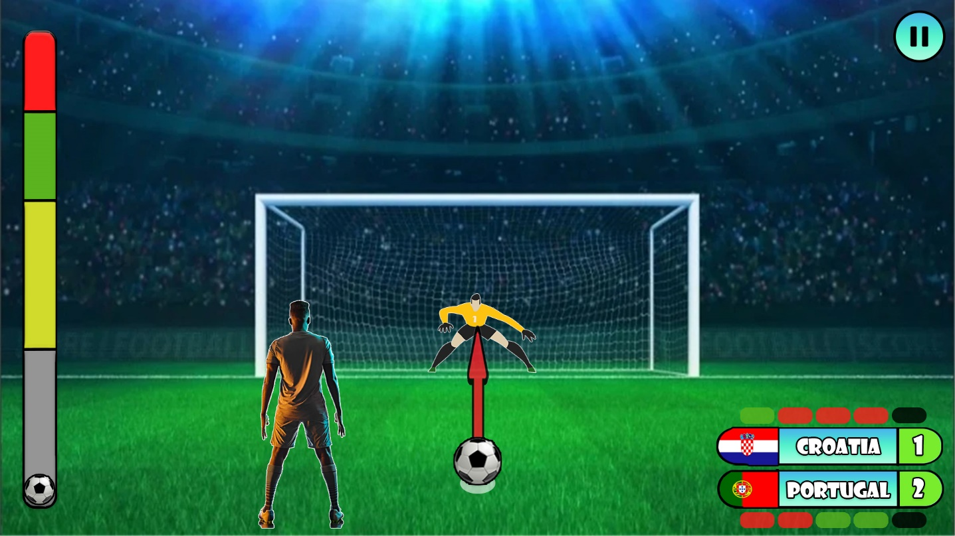

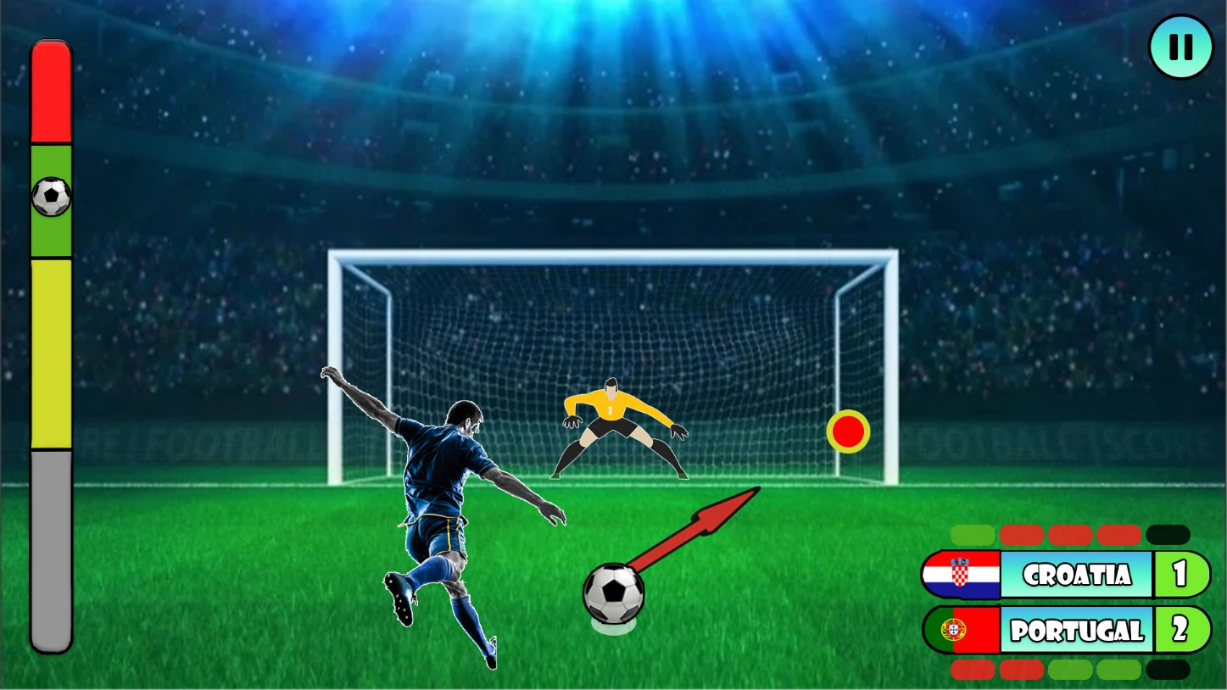

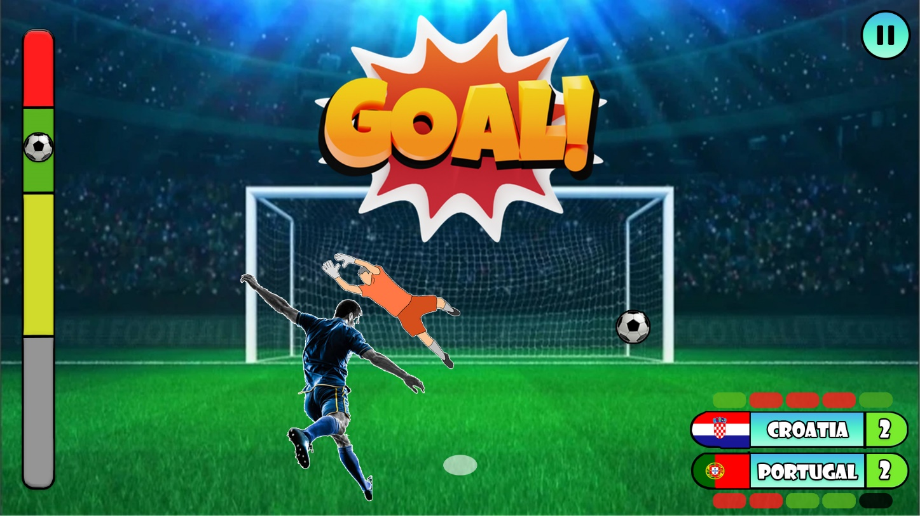

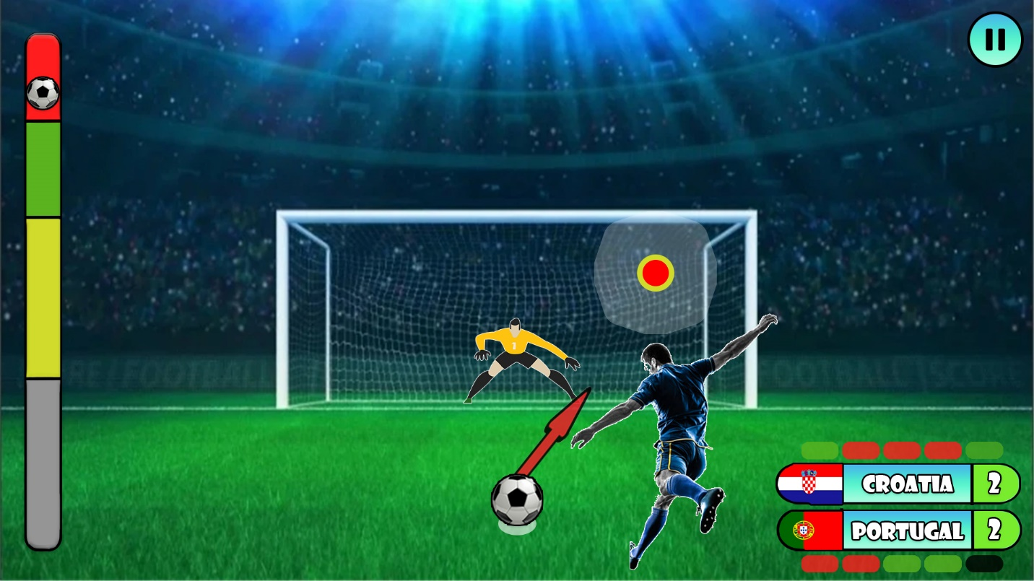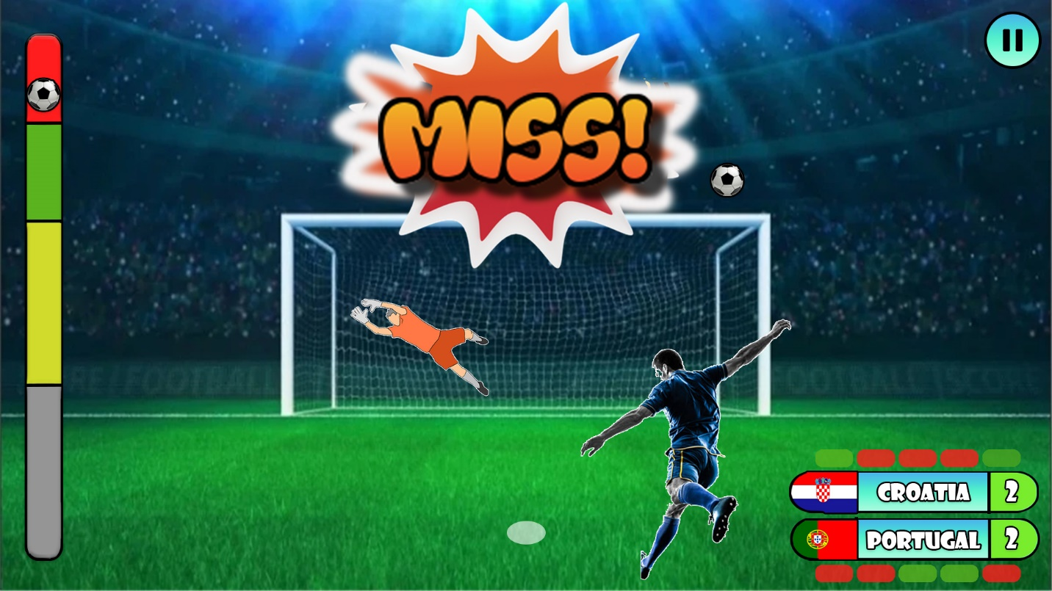

These are the 5 possible screens that you would see when taking a penalty in any game mode. First off all you would see a penalty scenario in a large football stadium in front of thousands of fans (alicdn.com, n.d.). This was a great image for taking a penalty in a stadium, making it great for the target audience of young teenagers because it is both visually appealing and helps set the atmosphere and pressure of a penalty scenario. Another interactive feature that the Penalty Shootout game would have been interactive football related sound effects such as football fans cheering and chanting in the background(Database, Large Football Crowd, 2022), the power bar charging up as the player holds their space bar waiting for the right moment and direction to release. The football (Pinimg.com, n.d.) is in the centre of the football goal with the arrow moving from side to side around the football, which indicates the direction the penalty is aiming at. The football player(iStockphoto.com, n.d.) and goalkeeper (Vexels.com, n.d.) have both been added to the experience so make the game feel more realistic, however these have only been put in as placeholders because in the future, the animations would be improved and the team kits for all teams would be added to give the authentic experience of two national teams playing each other.

I decided that holding the space bar to start charging the power bar and moving the arrow (Alzheimers.org.uk, n.d.) from side to side was a better control alternative because I thought that adding more control components would make penalties much more difficult. Since the game is the targeted for the youth, a simple control scheme would make the game simple to understand and would therefore be less frustrating and difficult to learn.

The power bar has been made in Adobe Photoshop to add more interactivity to the game by indicating the different power levels of shooting a penalty. The football will be moving up and down and its speed is determined by your team’s ATT score. If the space bar is released in the red, then the player has a very high chance of missing the penalty and a white glow will appear on the target showing that the ball will be shot in that direction but it very likely to miss and go off course. The green is the perfect power level and makes your shot more accurate, meanwhile the yellow is a light penalty makes it accurate but can be very slow and therefore makes it easier for the goalkeeper to save.

If the player has scored a penalty for their team, then a large “GOAL” celebration will appear on screen for a few seconds, and you will be able to hear large cheering by the fans in the background(PacTube, 2021)*.* If the player misses their shot, then a large “MISS” will appear on screen and the fans will make a frowning and disappointing sound (Database, Crowd Aww Sound, 2022). To be able to visually see the score how many penalties are left in real-time, I have made a team counter in the bottom right corner in Photoshop. This tally contains the country’s flag, their name, the points tally and on top/bottom the green and red colours indicating which penalties have been scored and which have been missed. It is updated regularly after each penalty which makes it more interactive and visually appealing.

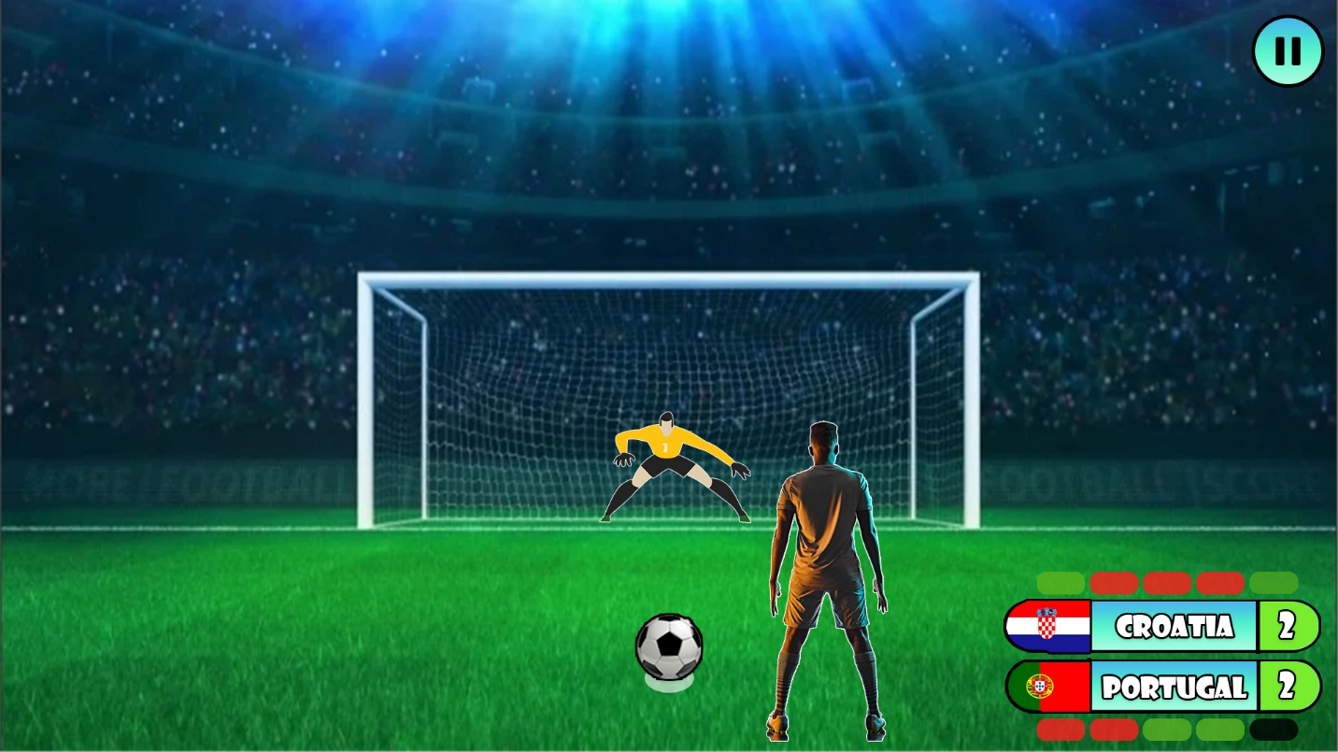

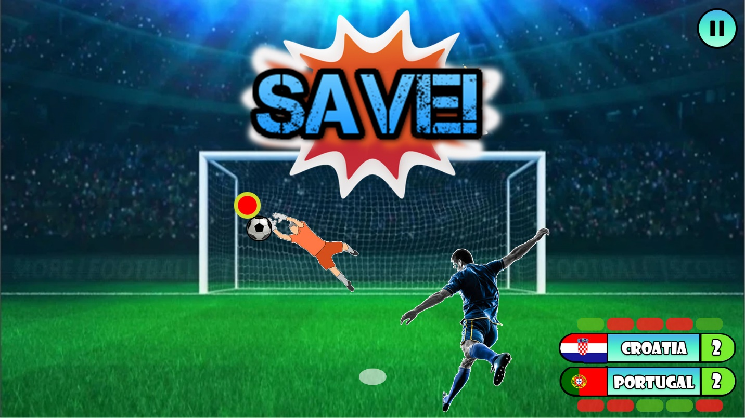

This would be the interface for the player is the goalkeeper and is waiting for the player to have their penalty. I have decided to remove the power bar because it is too many mechanics for the goalkeeper, and it would be much better to be reflex focussed. This would be better for the target audience because it means that anyone can play it without any previous experience with Penalty Shootout games. This means that the greater importance is to ensure you have a well-timed penalty rather than luck. The higher your team’s DEF score is, the ability for your goalkeeper to quickly move, react and save penalties is also much greater. If the penalty is saved by the goalkeeper of your team, then a large “SAVE” celebration will appear in the middle of the screen for a few seconds and your team will start cheering(Googleeman, 2022).

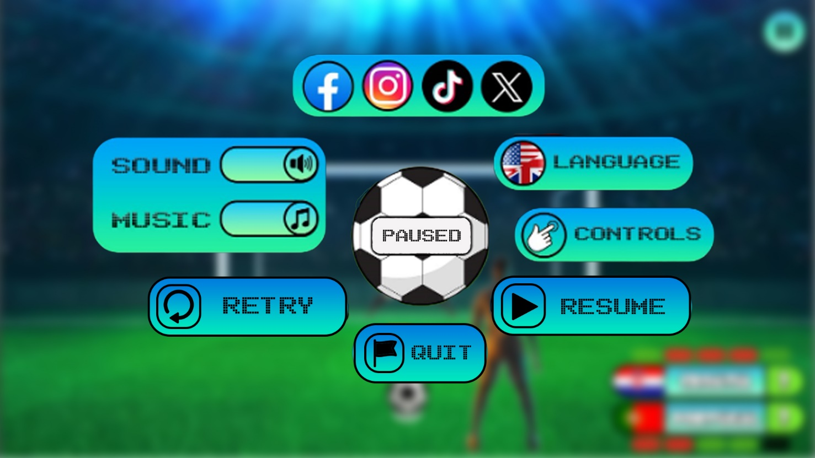

During a match, when you press the pause button (Pngall.com, n.d.) in the top right corner of the screen, the background blurs to make the player focus on the Pause Menu that has just appeared in the centre of the screen. It looks exactly the same like Options Menu from the Main Menu, except the football in the centre has the text “Paused” and some buttons have been replaced with new Retry(Thenounproject.com, n.d.), Resume (Pngtree.com, n.d.) and Quit (cdn-icons-png.flaticon.com, n.d.) buttons with their distinctive icons that allows the player to continue the match, quit back to the main menu and restart the match entirely.

**Multiplayer**

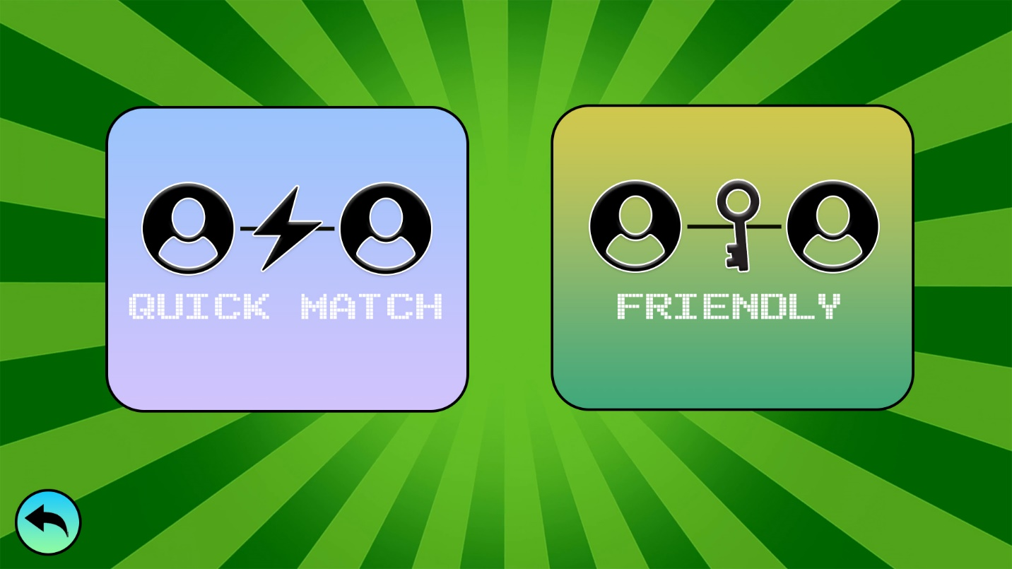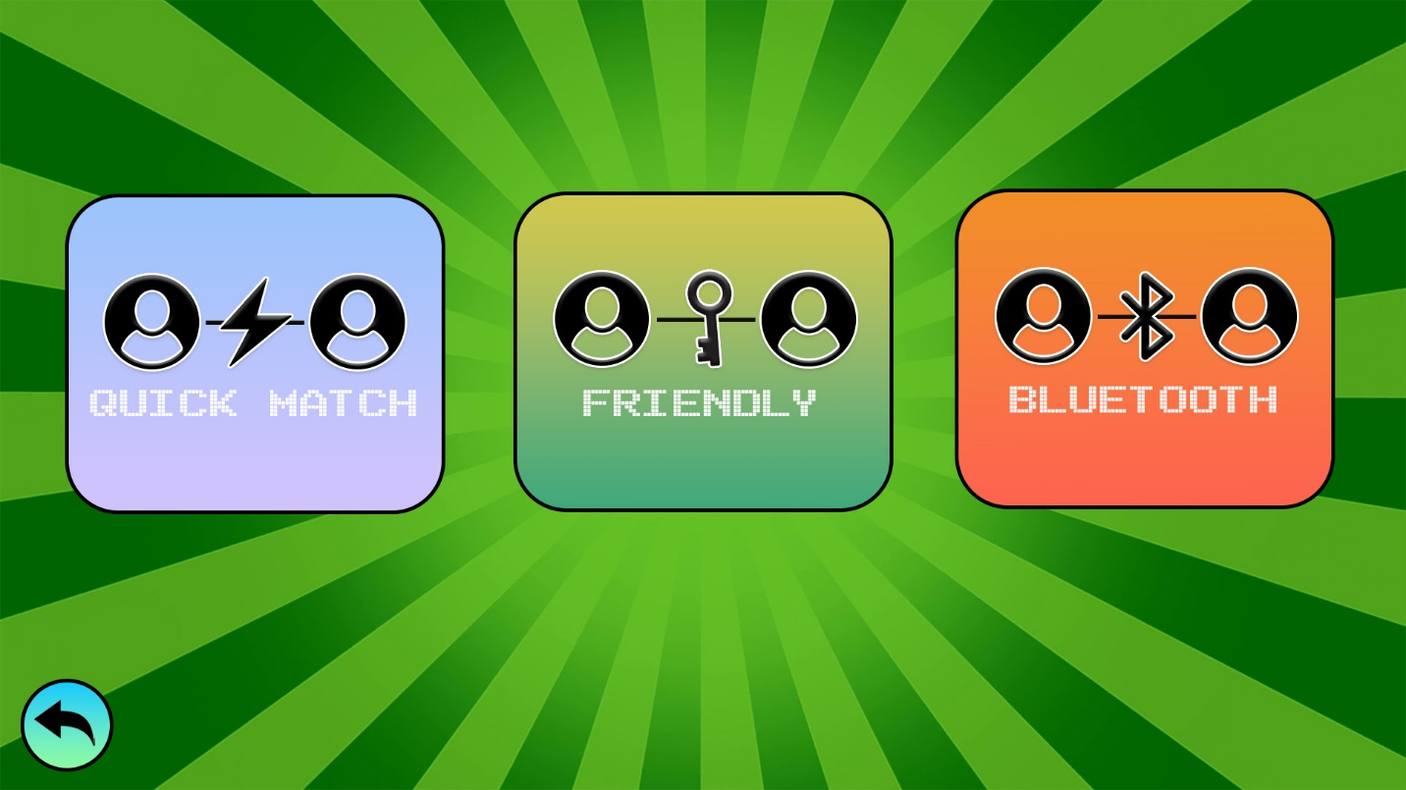

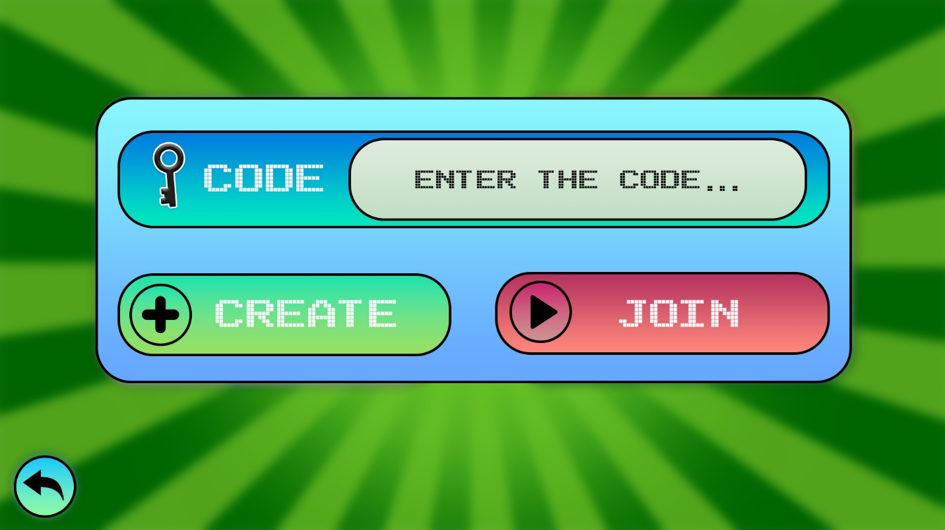

These are the 2 versions of the Multiplayer interface, the top one being the PC version of the game and the bottom one being the Mobile version of the Penalty Shootout game. I have decided to use large different coloured buttons in the middle of the screen that indicate the different types of Multiplayer modes. Quick Play is a quick and random game with random online players, Friendly is a friend-to-friend game through using a code, Bluetooth is for mobile phones in close proximity. This gives the target audience a variety of methods of playing Penalty Shootout online against their friends.

For the visual design, I have included user icons (svgrepo.com, n.d.) to represent players connecting to each other. The lightning icon (cdn-icons-png.flaticon.com, n.d.), key icon (vecteezy.com, n.d.)*,* Bluetooth icons (cdn-icons-png.flaticon.com, n.d.) help represent the type of connection between the players and using symbols to make it look more appealing with the variations of colours. At any time, the player can go back by clicking on the return button in the bottom left corner. If the player clicks on the friendly button, they can host and join a match with their friends using a code. The Create button has the plus icon (thenounproject.com, n.d.) and the Join button (veryicon.com, n.d.) has a play icon to further add interactivity to the game.

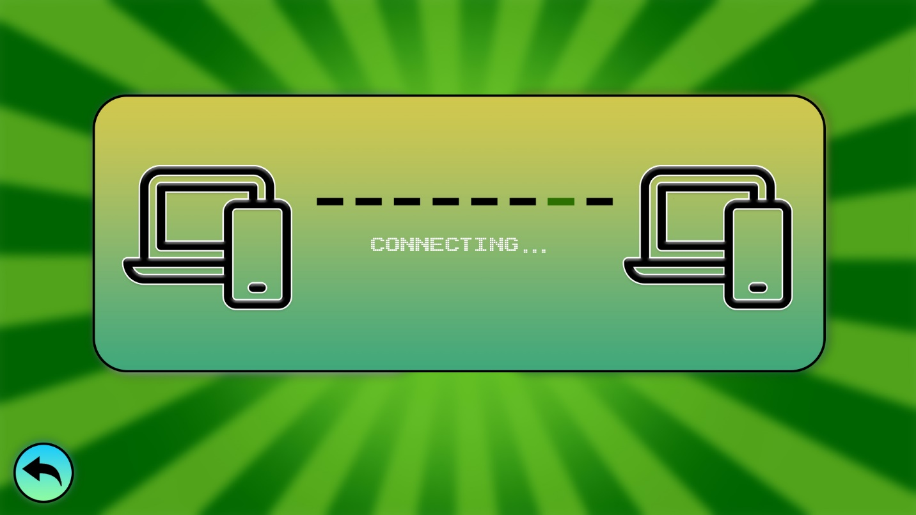

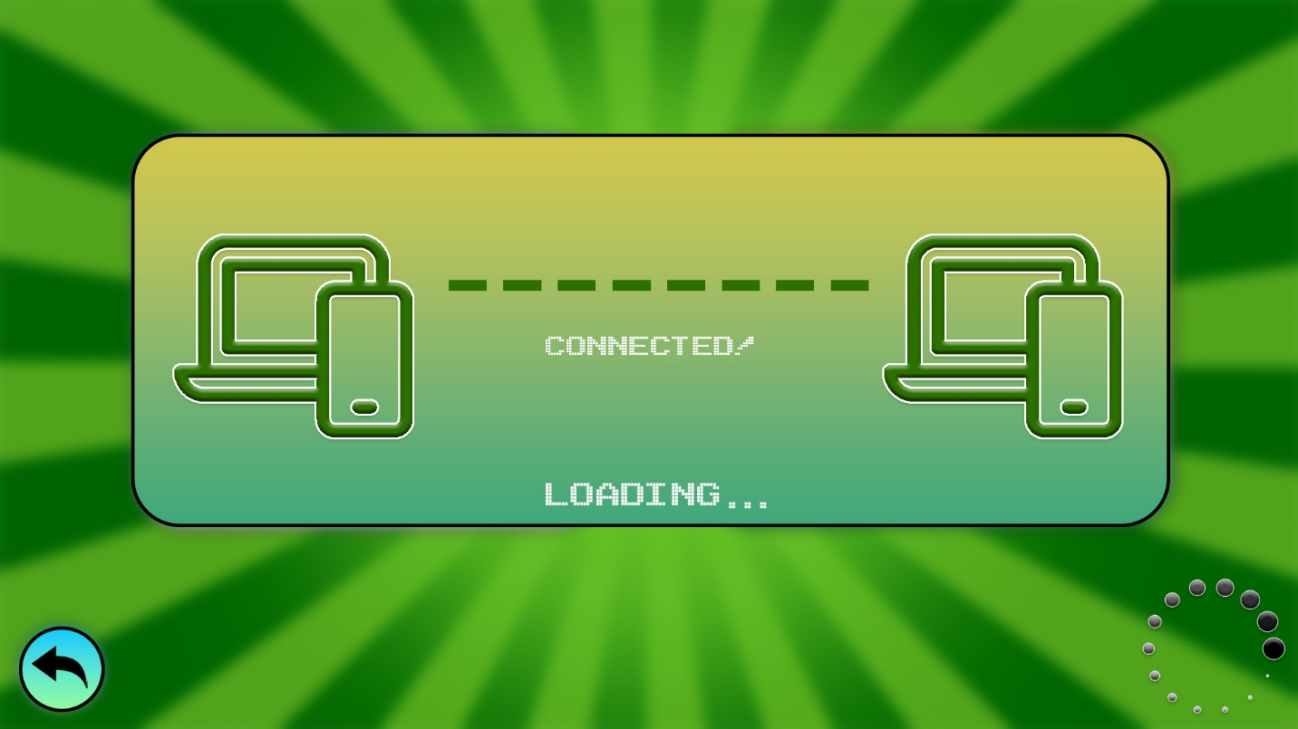

These are the screens that appear during the connection process before playing a Multiplayer game. The connection is visually represented through device icons (cdn.icon-icons.com, n.d.)showing a green connection to another device. While the devices are connecting, there will be an animation with a green bar moving through each black bar quickly back and forth between the devices until a connection is established. As soon as a connection is established the animation stops and both the connection and devices turn green. After this, a loading text appears and another animation of a spinning circle (png.pngtree.com, n.d.) in the bottom right of the screen while the connection is secured and the game loads for both users. This is better than just having loading text because it might take quite a long time loading into a multiplayer game over the internet and the player knows that the game is loading and has not crashed. To add even more interactivity the connecting menu will make a connecting sound effect (Root, n.d.) and when it connects to another player, it will make a satisfying connected sound effect (Tech, 2021).

**Arcade Mode**

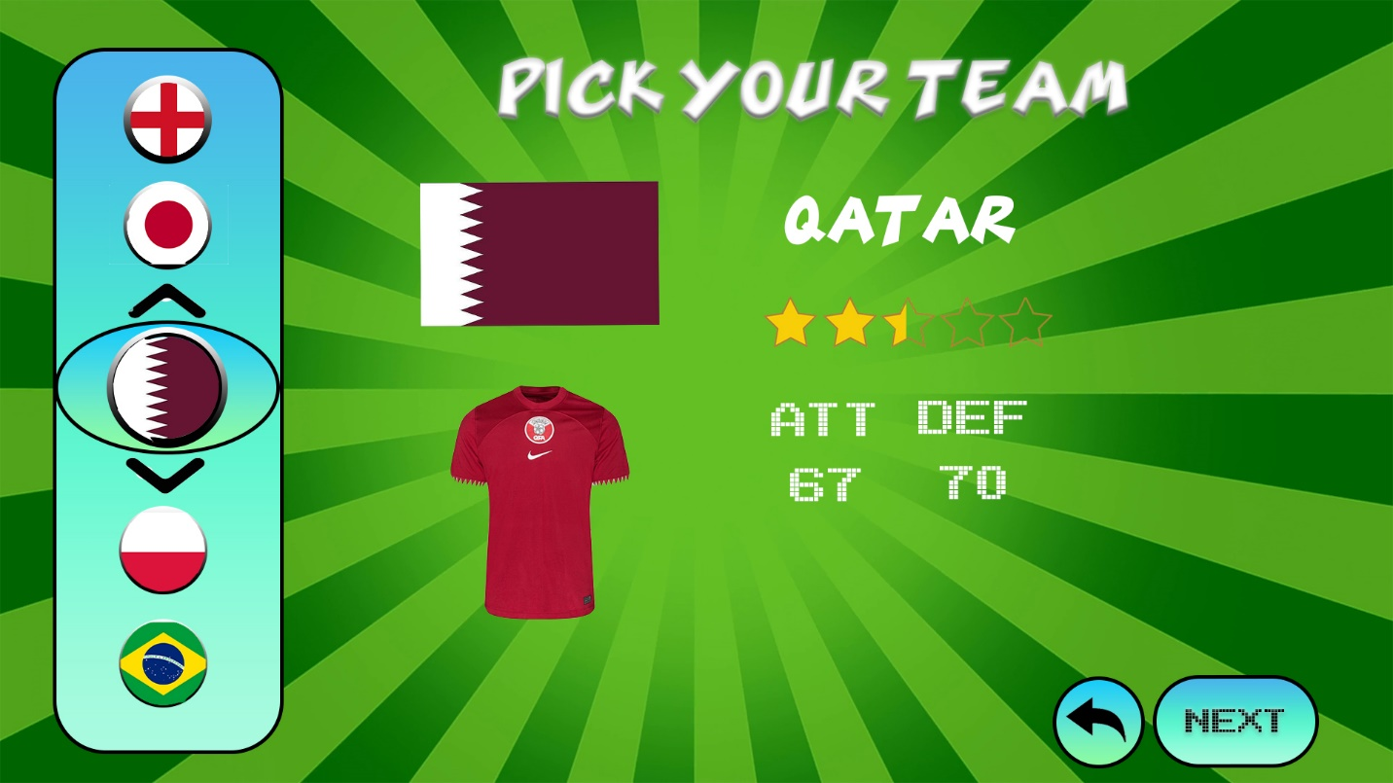

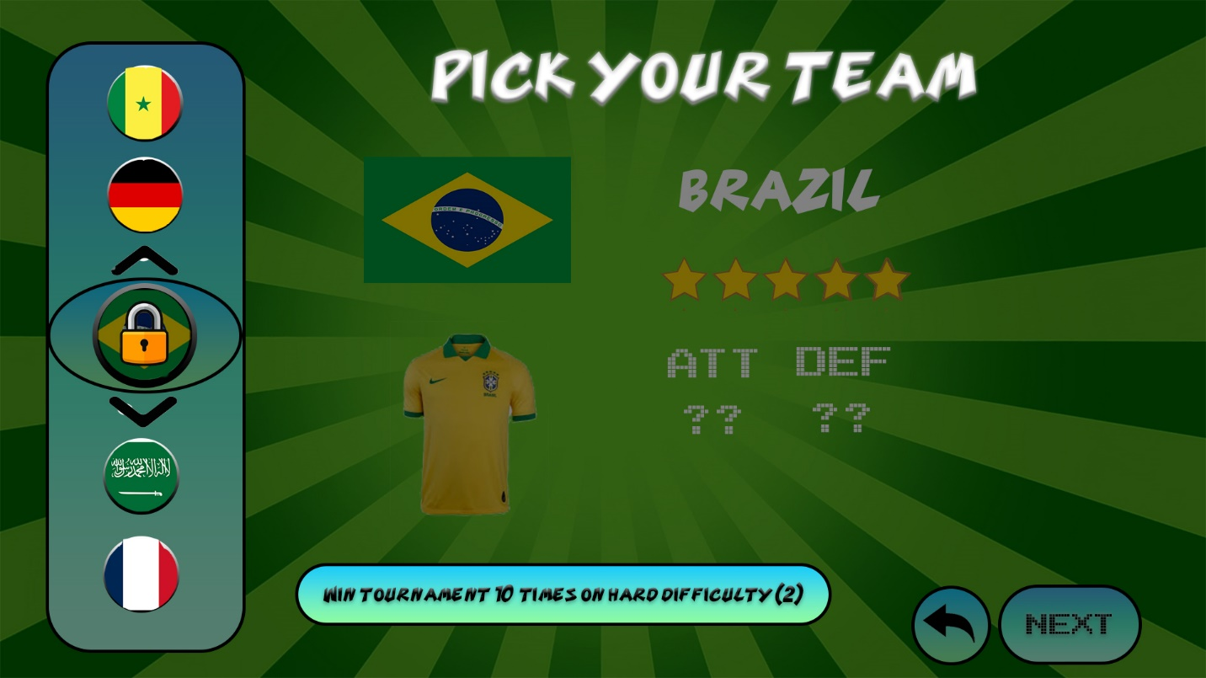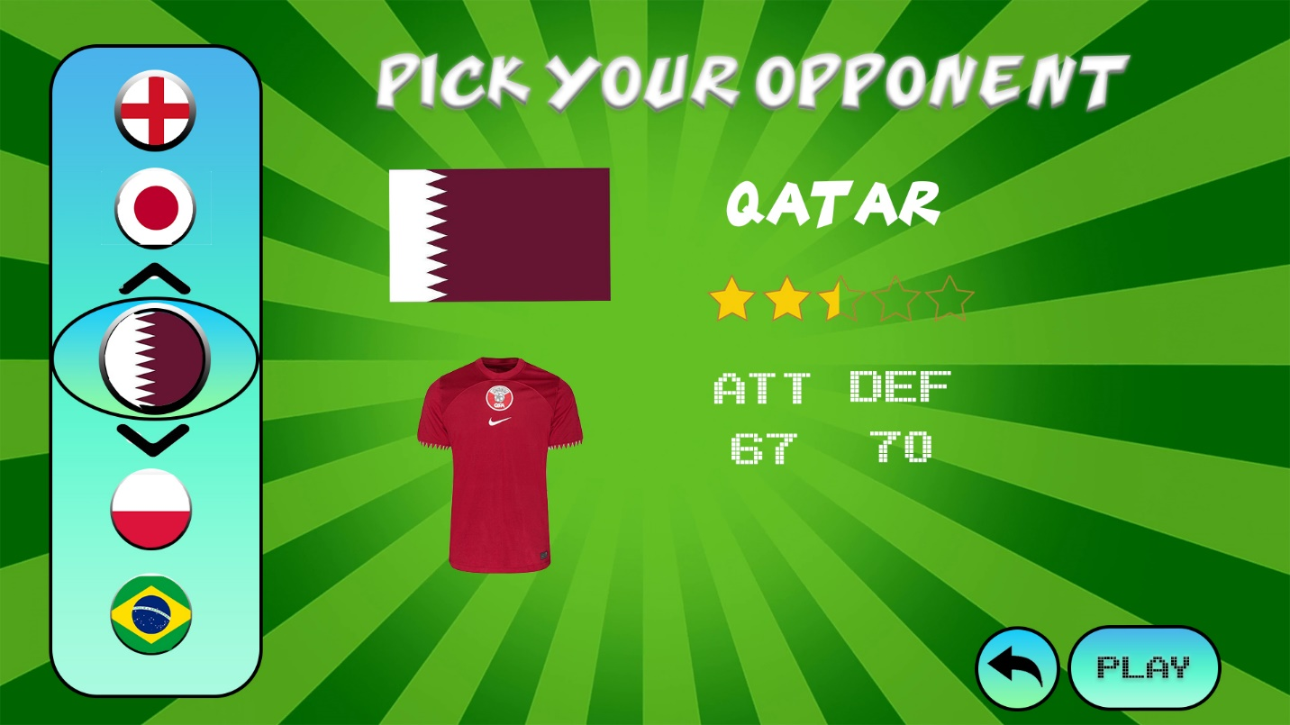

The Arcade Mode was designed in Adobe Photoshop to be visually appealing for young teenagers. I have created a simple yet with lots of things to keep it interesting, helping the attention span of the target audience. On the left of the Arcade Mode interface, we have a select team which the player would drag to the centre of the scroll wheel on the left of the screen or click on the arrow buttons in the centre to change the team, they wish to play. The scrolling between the team will make a scrolling arcade sound effect like the one in the Play Menu. For the first version of the game, all countries from the 2022 World Cup will be included in the Penalty Shootout game and each of them have their own kit (thumblr.uniid.it, n.d.), team star level out of 5 (cdn.pixabay.com, n.d.), ATT, and DEF scores.

To add greater interactivity to the Penalty Shootout game, I have decided to lock (t3.ftcdn.net, n.d.) many different teams with high star level and skill levels to give the player a reason to play other teams. This would encourage the player to try to unlock as many teams as possible by setting an unlocking objective for each national team. For example, to unlock the Brazil national team, the player must win the tournament 10 times on hard difficult which they have already completed 2 times. Other teams could have more specific objectives such as beating all 4-star teams in arcade mode, winning 25 multiplayer games, winning tournament without conceding a goal or beating all European teams in arcade mode. All the locked teams will have a dimmed background to tell the player that they are unavailable and the condition to unlock the team is bright, visible at the bottom of the screen.

At any time, the player can go back and return to the previous Play Menu by clicking the return button next to the next button. When the player has selected the team, they want to play, they click the next button on the bottom right of the screen to move to the next Pick Your Opponent screen. This looks the same as the Pick your Team menu, but the title at the top is different and the next button has changed to a play button.

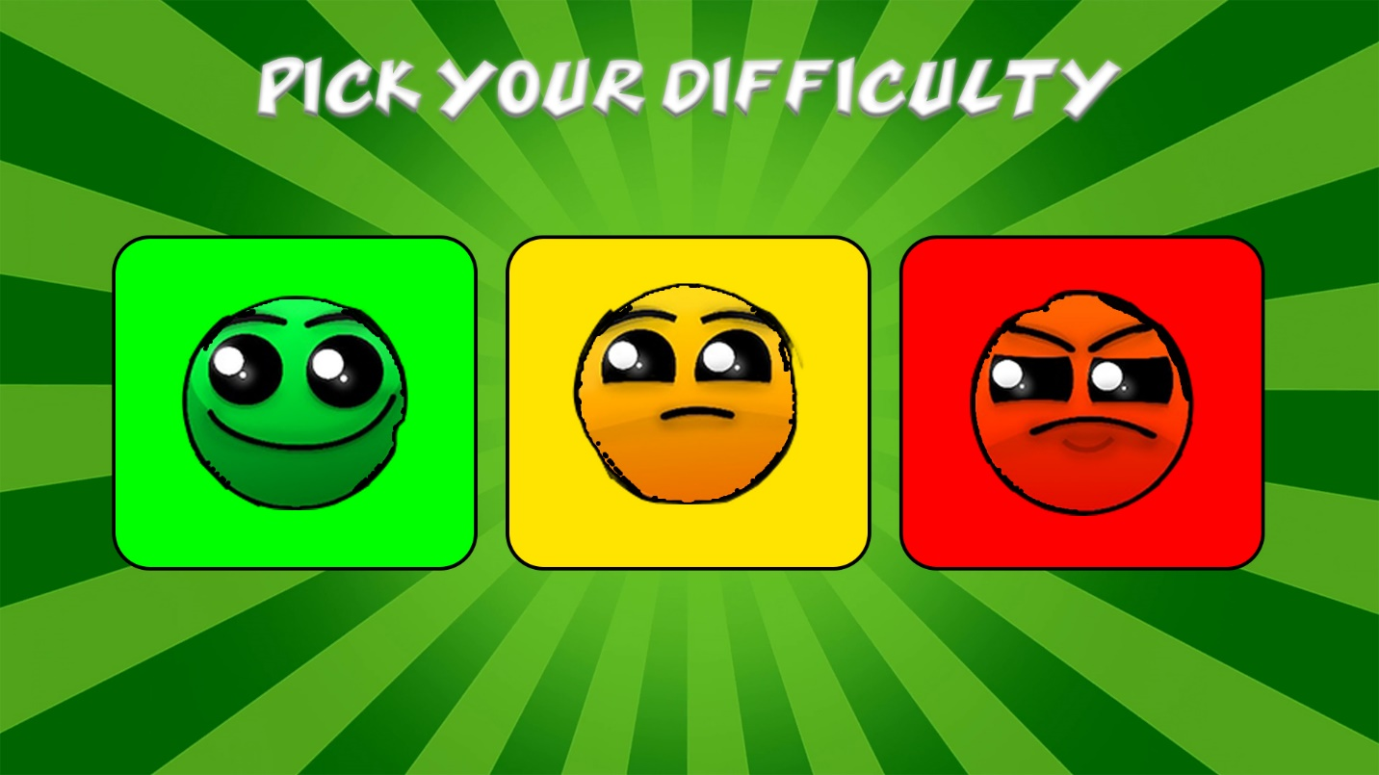

The last Arcade Menu, that the player must go through before they play the game is the Pick Your Difficulty menu. For this, I have decided to take away words and use simple visualisation using colours green, yellow, and red indicating easy, medium, and hard difficulties. Just in case the target audience got confused, ensured to include the title, Pick Your Difficulty to help avoid any confusion. The focus of this interface was simplicity and visualisation because a young teenager without any words needed, would be able to understand which of the buttons is easy and which of the buttons is hard difficulty. Depending on the button selected, the AI in the Penalty Shootout game will remember your penalty direction patterns and will try to be more realistic meaning it will be more difficult to score against and their skill level is higher.

**Tournament**



When you first enter the Tournament Mode on the Penalty Shootout game, you must select the team you wish to play the tournament with and after this you are prompted to select the difficulty level of the tournament. Both menus look the same as in the Arcade mode to ensure that the interface stays consistent and is easy to navigate with. However, depending on the difficulty selected by the player, the tournament teams will be adjusted to have higher overall star levels. For example, if the player selects hard mode, then the tournament teams will have 4.5-5-star level compared to easy more which will have 2.5-3.5-star national teams.

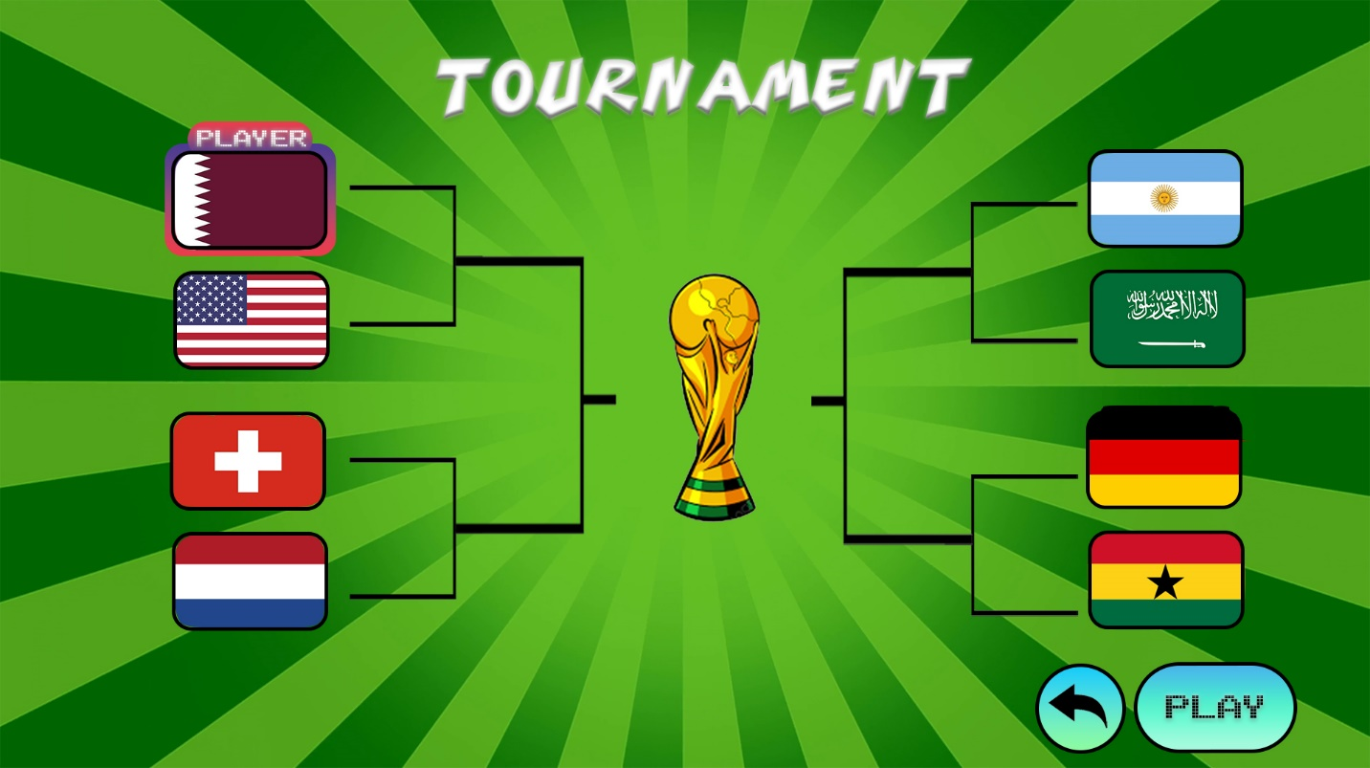

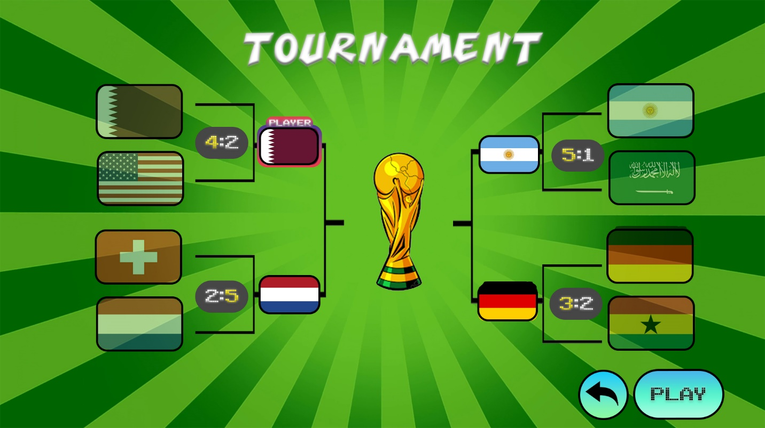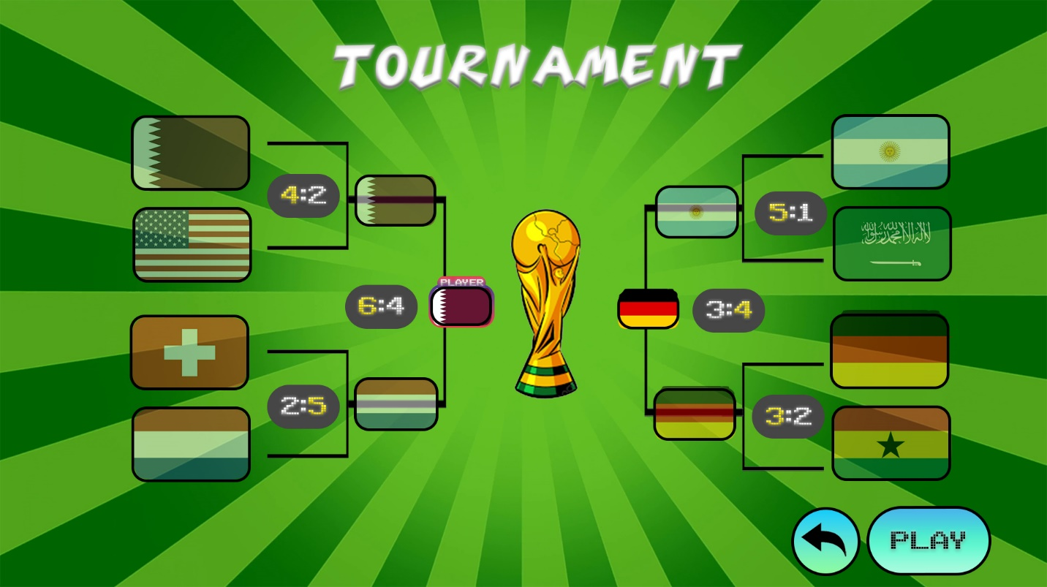

This is an example of the Tournament bracket layout of the Penalty Shootout game designed in Photoshop. In this layout, I have made sure to stay consistent, attractive, and simple to read and understand. Without a tournament menu like this, there would be empty, and the player would not be able to see which teams are participating, which teams are performing well and the scores of each match. This would further improve the interactivity of the game because young teenagers enjoy football tournaments such as the Euros and the World Cup. The resemblance of a real-life tournament by using a cartoon version of the World Cup trophy (png.pngtree.com, n.d.) in the centre of the tournament bracket would encourage the target audience to engage more with the various game modes this game has to offer. Instead of using words for the countries, the flags were a much better way of visually showing a tournament bracket because it they are colourful and simple to understand. Also, the team that the player had selected has a colourful border around with the subtext “player” so that it is easy to distinguish which flag is their team and who they would be playing against. At the beginning of the game the teams wouldn’t be visible for a moment while the teams are randomised for the interface to be more interactive.

After each match is played, the player is returned to this tournament bracket where all the team flags have a bumping animation against each other before the score and winners of each round are revealed. This bumping animation would have a satisfying bump sound effect (Studios, 2022) and then the flag is slowly moved to the next bracket while an arcade charge up sound effect is playing (DoomerReflex, 2021)*.* This is when the score is revealed between the teams with the winner glowing up in yellow. The losing teams are then turned slightly opaque so that the player can focus on the teams that are left in the tournament but can still see what teams they have played against. This process continues until the player either wins or loses the tournament.

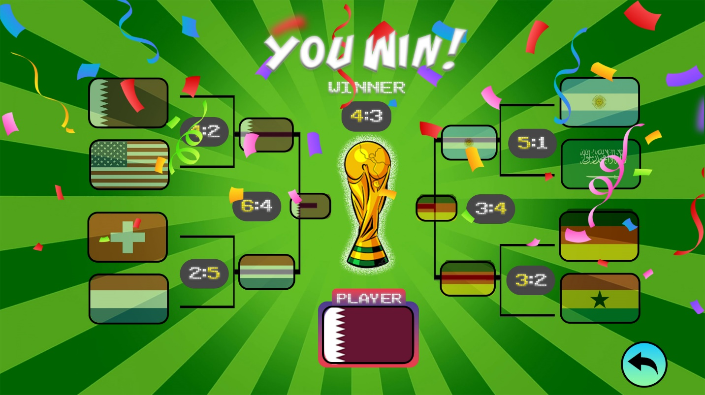

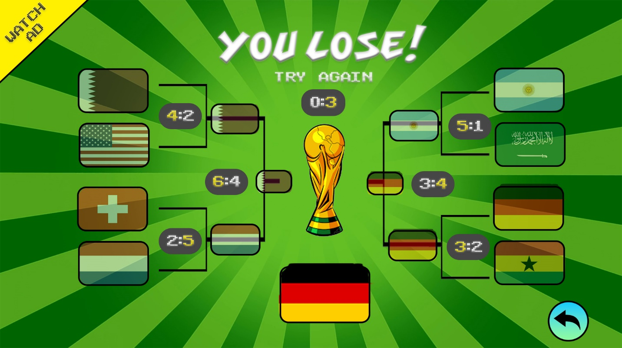

These are the You Win and You Lose screens that the player would see at the end of the Tournament. If the player wins the tournament, then the World Cup trophy starts to have a shine glow, the winner flag is displayed at the bottom of the screen and a massive You Win is on top of the screen. In celebration, the player also gets confetti (static.vecteezy.com, n.d.) and fans will start cheering in the background (Oggy, 2021). If you lose the tournament, then the trophy will not have any glow and there will be no confetti. Instead, to increase interactivity there would be sad/ disappointed fans in the background. However, common in mobile games is the ability to replay a lost match by watching an ad which is why I gave the option for the player in the top left corner.